

**AMERICAN INTERNATIONAL UNIVERSITY–BANGLADESH (AIUB)**

**DEPARTMENT OF ENGINEERING**

[**INTRODUCTION TO DATABASE**](https://portal.aiub.edu/Student/Section?q=j3Wc6QZpwj8GAUZ6rruD2A%3D%3D)

**Section: M, Group: 9**

**Project Name**

**PARKING SPOT MANAGEMENT SYSTEM**

**Supervised By**

**Kawser Irom Rushee**

**Submitted By**

|  |  |
| --- | --- |
| **ID** | **Name** |
| **22-47900-2** | **ARIFUR RAHMAN** |
| **22-46321-1** | **NAHID HASAN NOBIL** |
| **22-47894-2** | **MD. HEDAET SHAHRIAR HIMON** |
| **22-47045-1** | **TARIN SULTANA** |

**Date of Submission: 17 MAY,2023.**

TABLE OF CONTENTS

TOPICS

1.CASE STUDY

2.ER DIAGRAM

3.NORMALIZATION

4.TOTAL TABLE

5.FINAL TABLE

6.TABLE CRAETION AND DATA INSERTION

7.JOINNING

8.SUBQUERY

9.VIEW

10.CONSTRAINTS

**PARKING SPOT MANAGEMENT SYSTEM**

**Case Study:**

The parking spot management system has multiple employees who are supervised by managers, each manager overseeing one or more employees. The employees and managers are identified through unique employee and manager IDs, and their personal information such as first and last name, hire date, phone numbers, and salary are stored in the system. The managers are responsible for managing the parking spot as a whole, which is identified by a spot ID and has a own physical address. The parking spot contains several parking spaces, each with a unique space ID and type, which determines the cost rate for hiring the space on hourly or daily basis. Each space type also has a unique rate ID. Customers are assigned a parking slip upon hiring a space, which includes a slip ID, issue date, and expire date and type. The customers are identified through their own unique ID and their personal information, including first and last name, email address, phone numbers, license plate numbers, and address, is stored in the system. In order to better manage the parking spot and provide better services, there are various rules in place, and fines may be issued by the manager to customers who violate these rules. These fines include an ID, issue date, amount, and paid date.

**ER Diagram:**

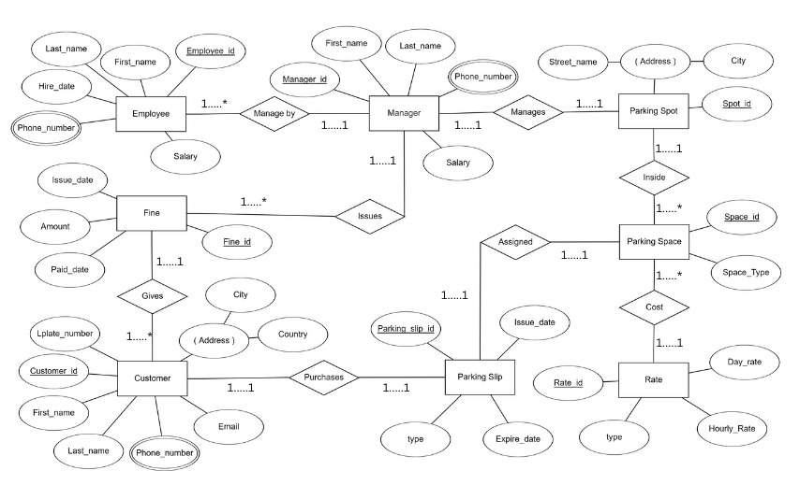

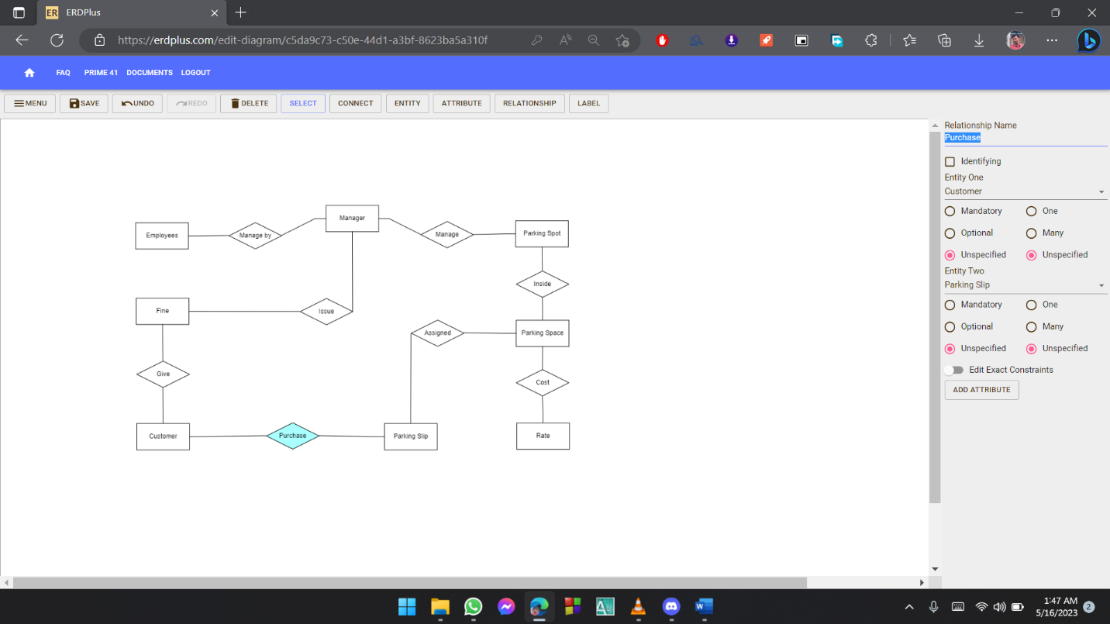

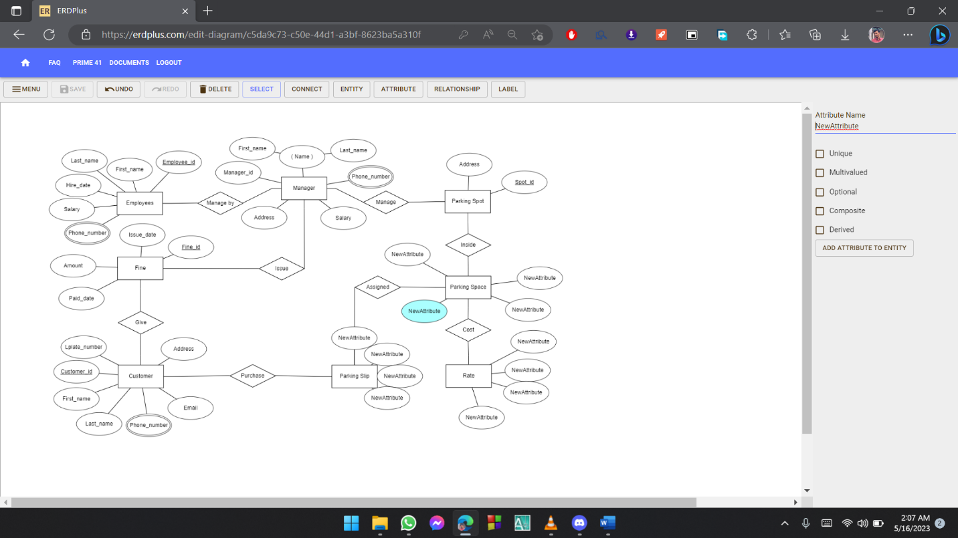

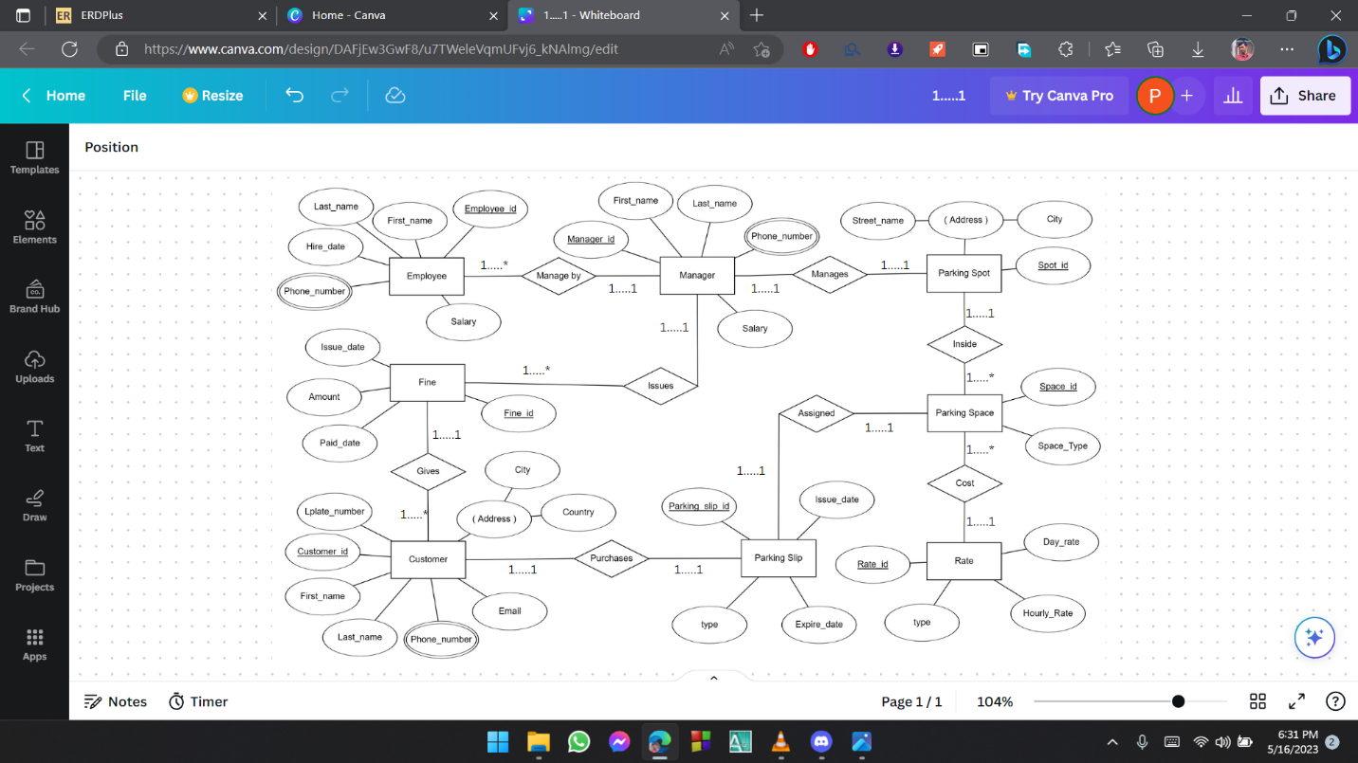

**Normalization of Database:**

**Inside**

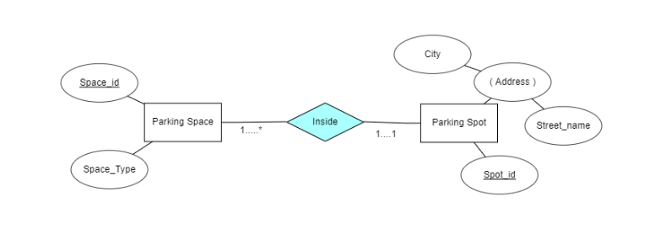

**UNF:** Spot_id, Street_no,City, Space_id, Space_type.

**1NF:** No multivalued attribute

Spot_id, Street_no,City, Space_id, Space_type

**2NF:** Spot_id, Street_no,City

Space_id, Space Type,Spot_id

**3NF:** Street_no,City has transitive dependency

Spot_id, Street_no,City

Space_id, Space_Type, Spot_id

**Table:** 1.Spot_id, Street_no,City

2.Space_id, Space_Type, Spot_id

**Cost**

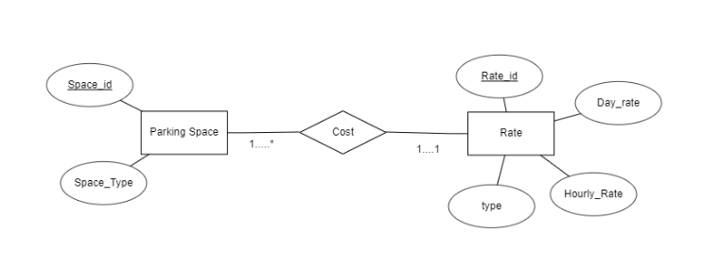

**UNF:** Space_id, Space_type, Rate_id, Hourly_rate, Day_Rate ,Type.

**1NF:** No multivalued attribute

Space_id, Space_type, Rate_id, Hourly_rate, Day_Rate, Type.

**2NF:** Space_id, Space_Type, Rate_id

Rate_id*,* Hourly_rate, Day_Rate,Type.

**3NF:** No transitive dependency

Space_id, Space_Type, Rate_id

Rate_id, Hourly rate, Day Rate,Type.

**Table:** 1.Space_id, Space Type, Rate_id

2.Rate_id, Hourly_rate, Day_Rate,Type

**Manages**

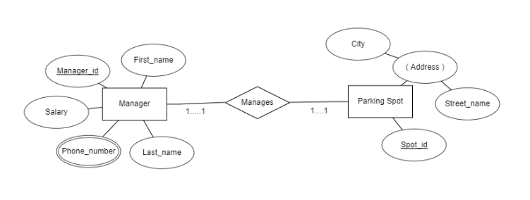

**UNF:**Spot_id, Street_no,City, Manager_id, Phone_number,

First_name,Last_name ,Salary

**1NF:** Phone_number multivalued attribute

Spot_id, Street_no,City, Manager_id, Phone_number,

First_name,Last_name, Salary

**2NF:** Spot_id, Street_no,City, Manager_id

Manager_id, First_name,Last_name, Salary

Phone_number, Manager_id

**3NF:** No transitive dependency

Spot_id, Street_no,City, Manager_id

Manager_id, First_name,Last_name,Salary

Phone_number, Manager_id

**Table:** 1.Spot_id, Street_no,City, Manager_id

2.Manager_id,First_name,Last_name,Salary

3.Phone_number, Manager_id

**Manage by**

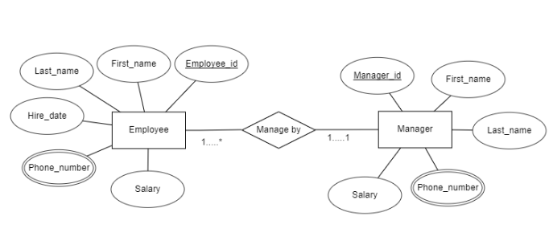

**UNF:** Manager_id , Phone_number , First_name,Last_name, Salary, Employee_id, First_Name , Last_Name , Hire_date, Salary, Phone_number

**1NF:** Phone_number multivalued attribute in employee and manager

Manager_id , Phone_number , First_name,Last_name,

Salary, Employee_id, First_Name , Last_Name ,

Hire_date, Salary,Phone_number

**2NF:** 1.Manager_id, First_name,Last_name,Salary

2.Phone_number, Manager_id

3.Employee_id, First_Name, Last_Name, Hire_date, Salary,

Manager_id

4.Phone_number, Employee_id

**3NF:** No transitive dependency

1.Manager_id , First name,Last name,Salary

2.Phone_number, Manager_id

3.Employee_id, First Name , Last Name , Hire date, Salary,

Manager_id

4.Phone_number, Employee_id

**Table:**1.Manager_id, First name,Last name,Salary

2.Phone_number, Manager_id

3.Employee_id, First_Name , Last_Name , Hire_date, Salary,

Manager_id

4.Phone_number, Employee_id

**Assigned**

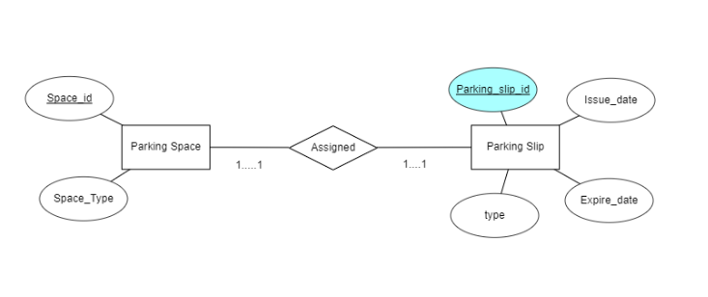**UNF:** Space_id,Space_Type,Parking_slip_id,Issue_date,Expire_date,

Type

**1NF:** No multivalued attribute

1. Space_id,Space_Type,Parking_slip_id,Issue_date,Expire_date,

Type

**2NF:** 1.Space_id, Space Type

2.Parking_slip_id,Issue_date,Expire_date,Type,Space_id

**3NF:** No transitive dependency

1.Space_id,Space_Type

2.Parking_slip_id,Issue_date,Expire_date,Type,Space_id

**Table:** 1. Space_id,Space_type

2.Parking_slip_id,Issue_date,Expire_date,Type,Space_id

**Purchases**

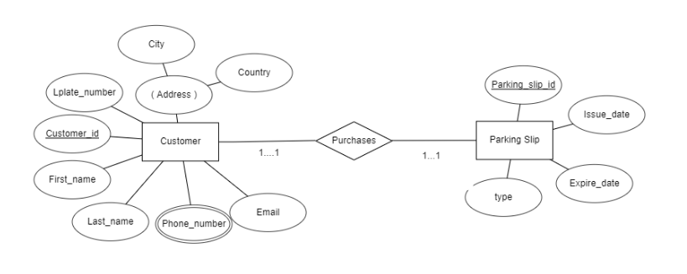

**UNF:** Customer_id,First name,Last name,Email,City,Country

Phone_number,Lplate_number,Parking_slip_id,Issue_date,

Expire date,Type

**1NF:** Phone number multivalued attribute

Customer_id,First_name,Last_name,Email,City,Country,

Phone_number, Lplate_number, Parking_slip_id,

Issue_date, Expair date,Type

**2NF:** 1.Customer_id,First name,Last name,Email,City,Country,

Lplate_number

2.Parking_slip_id,Issue_date,Expire date,Type,Customer_id

3.Phone_number , Customer_id

**3NF:** City,Country has transitive dependency

1.Customer_id,First name,Last name,Email,Lplate_number

2 Customer_id,City,Country

3.Parking_slip_id,Issue date,Expair date,Type,Customer_id

4.Phone_number, Customer_id

**Table:**1.Customer_id,First_name,Last_name,Email,Lplate_number

2 Customer_id,city,country

3.Parking_slip_id,Issue_date,Expair_date,Type,Customer_id

4.Phone_number, Customer_id

**Gives**

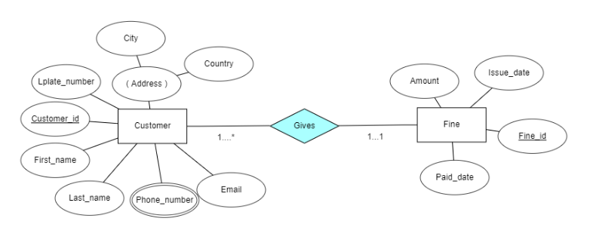

**UNF:** Customer_id,First_name,Last_name,Email, City,Country

Phone_number,Lplate_number,Fine_id ,Issue _date,

Paid_date,Amount

**1NF:** Phone_number multivalued attribute

Customer_id,First_name,Last_name,Email, City,Country,

Phone_number,Lplate_number,Fine_id ,Issue _date,

Paid_date,Amount

**2NF:** 1. Customer_id,First_name,Last_name,Email, City,Country,

Lplate_number,Fine_id

2.Fine_id, Issue_date,Paid_date,Amount

3.Phone_number, Customer_id

**3NF:** City,Country has transitive dependency

1.Customer_id,First_name,Last_name,Email,

Lplate_number,Fine_id

2. Customer_id, City,Country

3.Fine_id, Issue_date,paid_date,Amount

4.Phone_number, Customer_id

**Table:** 1.Customer_id,First_name,Last_name,Email,

Lplate_number,Fine_id

2. Customer_id, City,Country

3.Fine_id, Issue_date,Paid_date,Amount

4.Phone_number, Customer_id

**Issues**

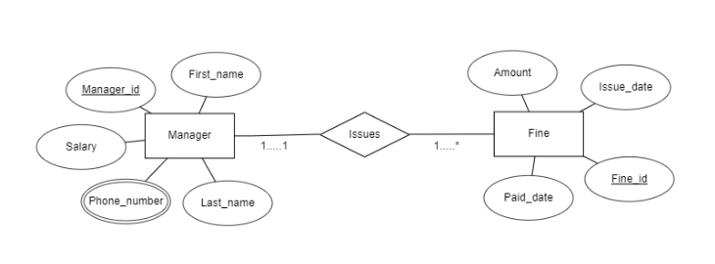

**UNF:** Manager_id, Phone_number,Fine_id,Issue_date,

Paid date,Amount

**1NF:** Phone_number multivalued attribute

Manager_id, First_name,Last_name,

Salary,Phone_number,Fine_id,Issue date,Paid date,Amount

**2NF:** 1. Manager_id, First name,Last name,Salary

2.Fine_id,Issue date, Paid date,Amount,Manager id

3.Phone_number, Manager_id

**3NF:** No transitive dependency

1.Manager_id, First name,Last name,Salary

2.Fine_id,Issue_date, Paid_date,Amount,Manager_id

3.Phone_number, Manager_id

**Table:**1.Manager_id, First name,Last name,Salary

2.Fine_id,Issue_date, Paid_date,Amount,Manager_id

3.Phone_number, Manager_id

**Total Table:**

1.Spot_id, Street_no,City

2.Space_id, Space_Type, Spot_id

3.Space_id, Space Type, Rate_id

4.Rate_id, Hourly_rate, Day_Rate,Type

5.Spot_id, Street_no,City, Manager_id

6.Manager_id,first_name,last_name,Salary

7.Phone_number, Manager_id

8.Manager_id, First name,Last name,Salary

9.Phone_number, Manager_id

10.Employee_id, First_Name , Last_Name , Hire_date, Salary,

Manager_id

11.Phone_number, Employee_id

12.Space_id,Space_type

13.Parking_slip_id,Issue_date,Expire_date,Type,Space_id

14.Customer_id,First_name,Last_name,Email,Lplate_number

15.Customer_id,City,Country

16.Parking_slip_id,Issue_date,Expair_date,Type,Customer_id

17.Phone_number, Customer_id

18.Customer_id,First_name,Last_name,Email,Lplate_number,Fine_id

19.Customer_id, City,Country

20.Fine_id, Issue_date,Paid_date,Amount

21.Phone_number, Customer_id

22.Manager_id, First name,Last name,Salary

23.Fine_id,Issue_date, Paid_date,Amount,Manager_id

24.Phone_number, Manager_id

**Final Table:**

1.Space_id, Space_Type, Spot_id

2.Space_id, Space Type, Rate_id

3.Rate_id, Hourly_rate, Day_Rate,Type

4.Spot_id, Street_no,City, Manager_id

5.Manager_id,First_name,Last_name,Salary

6.Phone_number, Manager_id

7.Employee_id, First_Name , Last_Name , Hire_date, Salary,

Manager_id

8.Phone_number, Employee_id

9.Parking_slip_id,Issue_date,Expire_date,Type,Space_id

10.Customer_id,City,Country

11.Parking_slip_id,Issue_date,Expair_date,Type,Customer_id

12.Phone_number, Customer_id

13.Customer_id,First_name,Last_name,Email,Lplate_number,

Fine_id

14.Fine_id,Issue_date, Paid_date,Amount,Manager_id

**Table Creation And Data Insertion:**

**MANAGER TABLE:**

create table manager

( manager_id number(5) constraint mid_pk primary key,

first_name varchar2(20) not null,

last_name varchar2(20) not null,

salary number(10) not null)

desc manager

drop table manager

insert into manager(manager_id,first_name,last_name,salary) values (150,'Arifur Rahman','Shezann',5000)

insert into manager(manager_id,first_name,last_name,salary) values (250,'Nahid Hasan','Nobil',500000)

insert into manager(manager_id,first_name,last_name,salary) values (350,'Hedaet Shahriar','Himon',7900)

insert into manager(manager_id,first_name,last_name,salary) values (450,'Tarin Sultana','Chaity',8200)

select * from manager

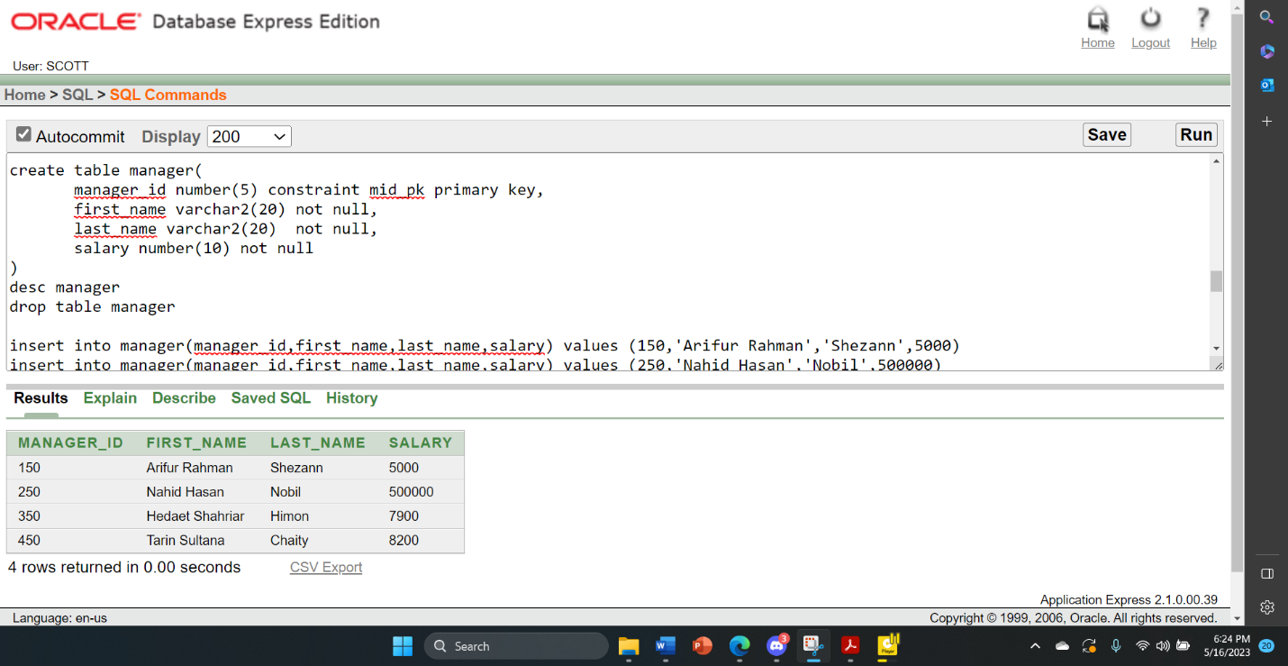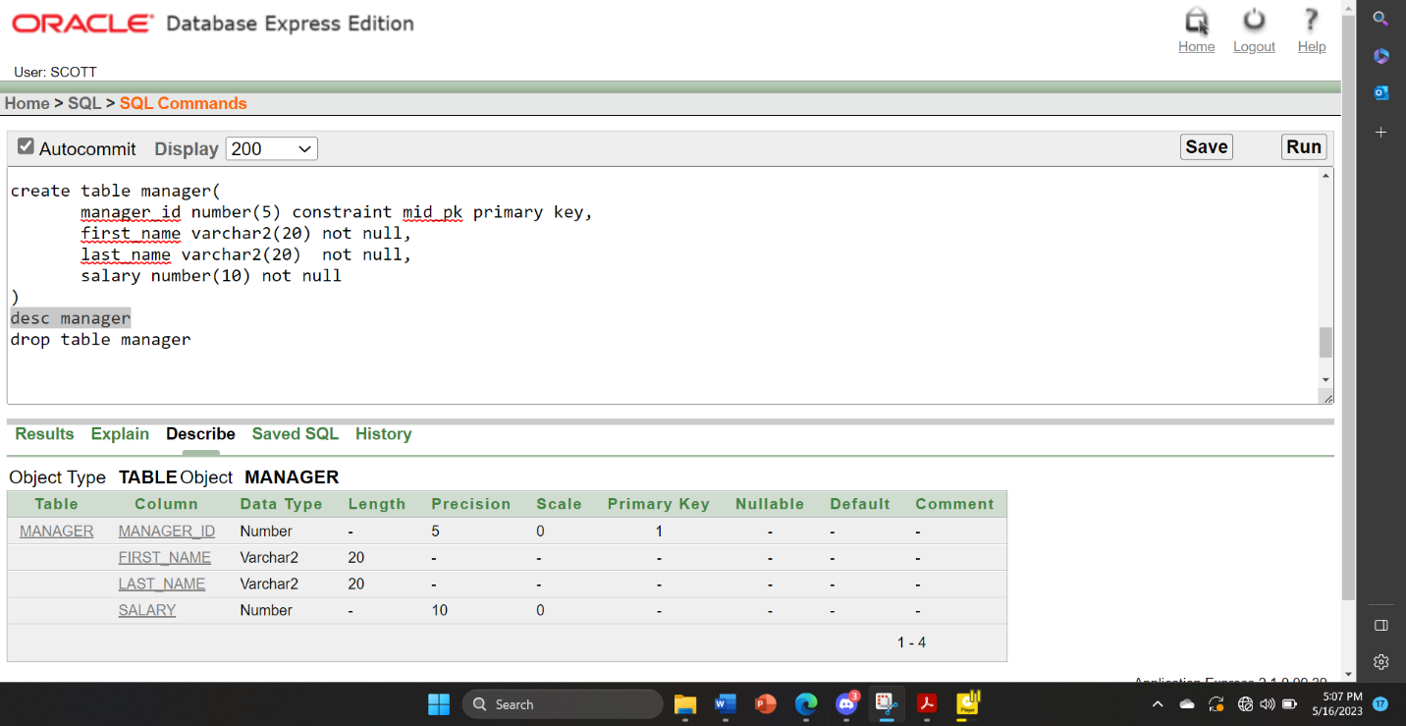

**M_PHONENUMBER TABLE:**

create table m_phonenumber

( phone_number number(11) unique not null,

manager_id number(5) constraint mid_fk references manager(manager_id) not null)

desc m_phonenumber

drop table m_phonenumber

insert into m_phonenumber(manager_id,phone_number) values (150, 01865454574)

insert into m_phonenumber(manager_id,phone_number) values (250, 01765456785)

insert into m_phonenumber(manager_id,phone_number) values (350, 01965453876)

insert into m_phonenumber(manager_id,phone_number) values (450, 01334334345)

select * from m_phonenumber

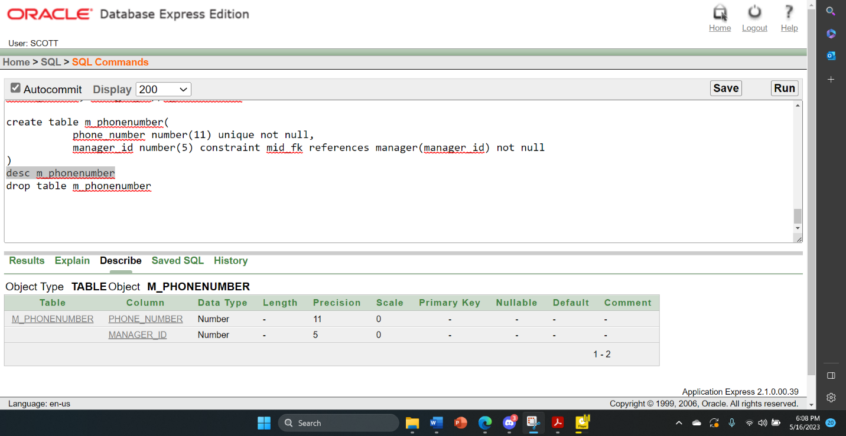

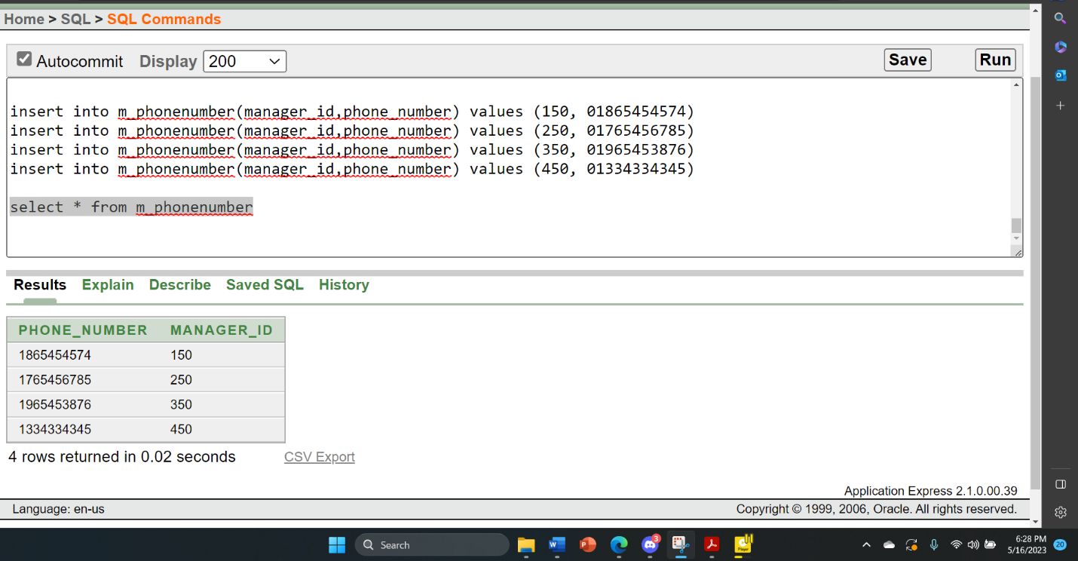

**PARKINGSPOT TABLE:**

create table parkingspot

( spot_id number(5)constraint spotid_pk primary key,

street_no number(10) unique not null,

city varchar2(20) not null,

manager_id number(5) constraint mnid_fk references manager(manager_id) not null)

desc parkingspot

drop table parkingspot

insert into parkingspot(spot_id,street_no,city,manager_id) values (10,8,'Coxs-Bazar',150)

insert into parkingspot(spot_id,street_no,city,manager_id) values (20,13,'Tangail',250)

insert into parkingspot(spot_id,street_no,city,manager_id) values (30,21,'Mymensing',350)

insert into parkingspot(spot_id,street_no,city,manager_id) values (40,3,'Joshor',450)

select * from parkingspot

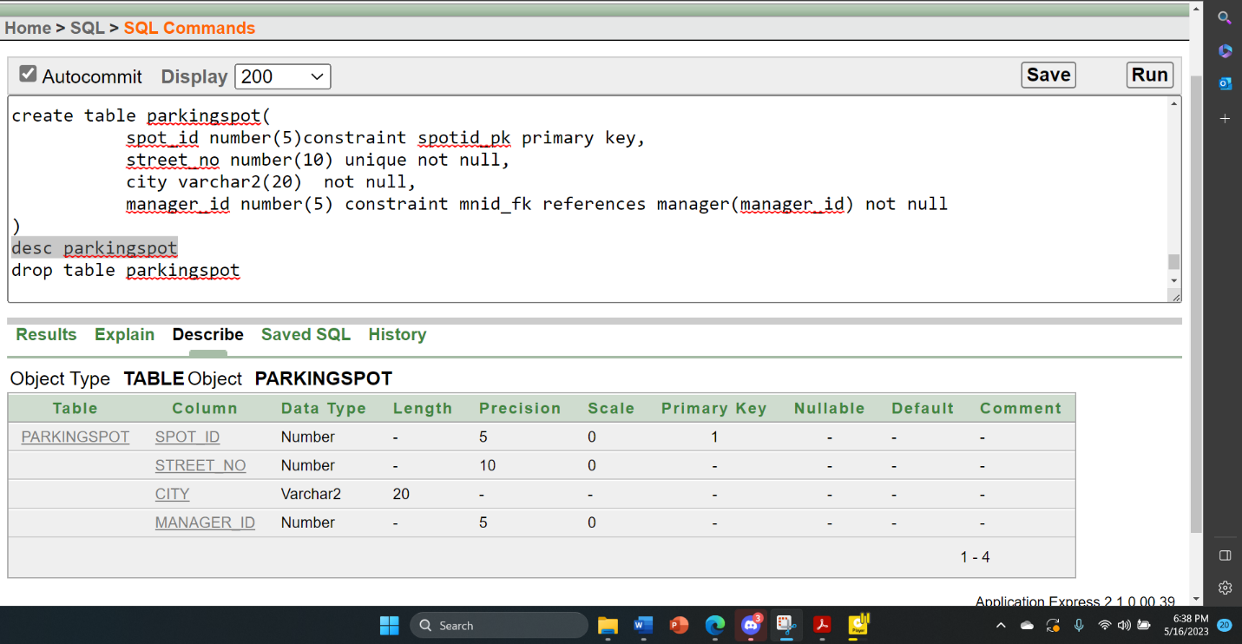

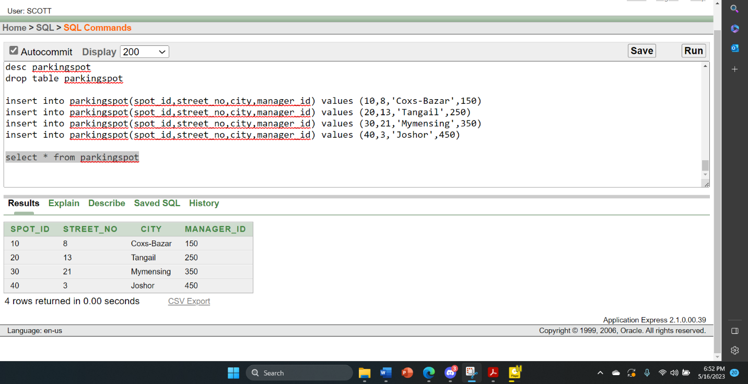

**PARKINGSPACE TABLE:**

create table parkingspace

( space_id number(5) constraint spid_pk primary key,

space_type varchar2(20) check( space_type in ('Small','Medium','Large')) not null,

spot_id number(5) constraint spotid_fk references parkingspot(spot_id) not null )

desc parkingspace drop table parkingspace

insert into parkingspace (space_id,space_type,spot_id) values(1,'Large',10)

insert into parkingspace (space_id,space_type,spot_id) values(2,'Small',10)

insert into parkingspace (space_id,space_type,spot_id) values(3,'Large',10)

insert into parkingspace (space_id,space_type,spot_id) values(4,'Small',40)

insert into parkingspace (space_id,space_type,spot_id) values(5,'Medium',20)

insert into parkingspace (space_id,space_type,spot_id) values(6,'Small',20)

insert into parkingspace (space_id,space_type,spot_id) values(7,'Large',20)

insert into parkingspace (space_id,space_type,spot_id) values(8,'Medium',40)

insert into parkingspace (space_id,space_type,spot_id) values(9,'Medium',30)

insert into parkingspace (space_id,space_type,spot_id) values(10,'Medium',30)

insert into parkingspace (space_id,space_type,spot_id) values(11,'Large',30)

insert into parkingspace (space_id,space_type,spot_id) values(12,'Medium',40)

select * from parkingspace

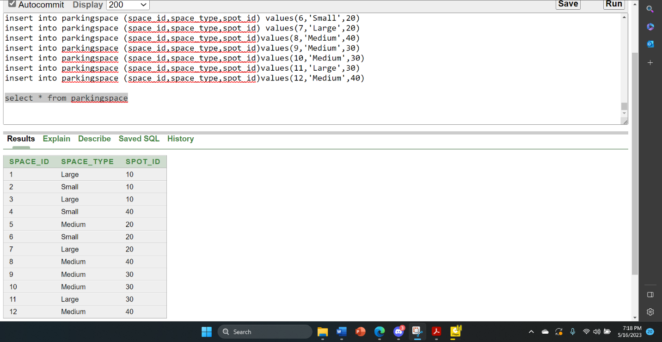

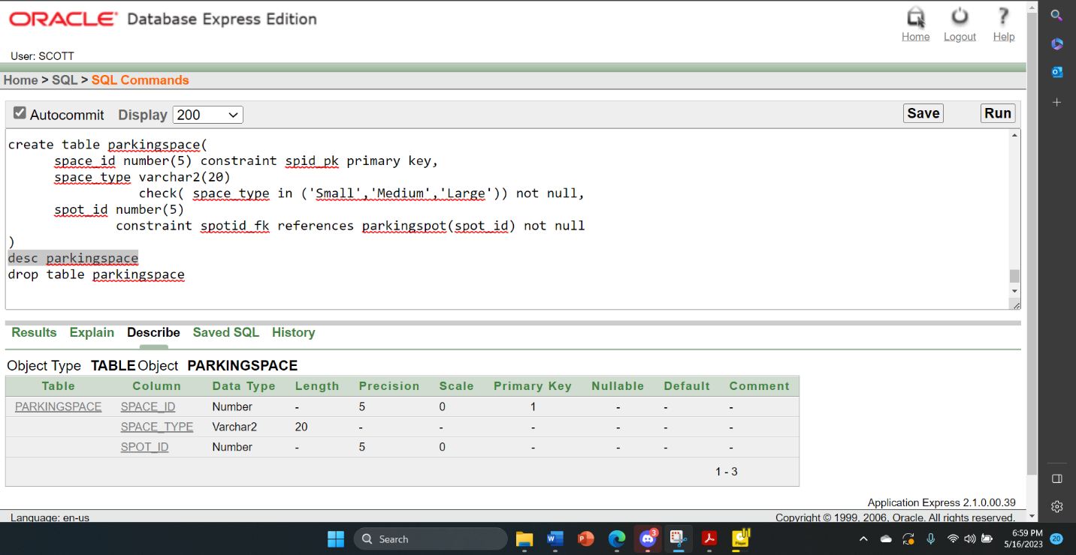

**R_PARKINGSPACE TABLE:**

create table r_parkingspace

( space_id number(5) constraint sid_pk primary key,

type varchar2(20) check(type in ('Small','Medium','Large')),

rate_id number(5) constraint rid_fk references rate(rate_id))

desc r_parkingspace

drop table r_parkingspace

create sequence space_id_seq

increment by 1

start with 1

maxvalue 300

insert into r_parkingspace(space_id,type,rate_id) values (space_id_seq.nextval,'Small',1)

insert into r_parkingspace(space_id,type,rate_id) values (space_id_seq.nextval,'Large',2)

insert into r_parkingspace(space_id,type,rate_id) values (space_id_seq.nextval,'Small',3)

insert into r_parkingspace(space_id,type,rate_id) values (space_id_seq.nextval,'Small',4)

insert into r_parkingspace(space_id,type,rate_id) values (space_id_seq.nextval,'Medium',5)

insert into r_parkingspace(space_id,type,rate_id) values (space_id_seq.nextval,'Large'6)

insert into r_parkingspace(space_id,type,rate_id) values (space_id_seq.nextval,'Large',7)

insert into r_parkingspace(space_id,type,rate_id) values (space_id_seq.nextval,'Small',8)

insert into r_parkingspace(space_id,type,rate_id) values (space_id_seq.nextval,'Medium',9)

insert into r_parkingspace(space_id,type,rate_id) values (space_id_seq.nextval,'Medium',10)

select * from r_parkingspace

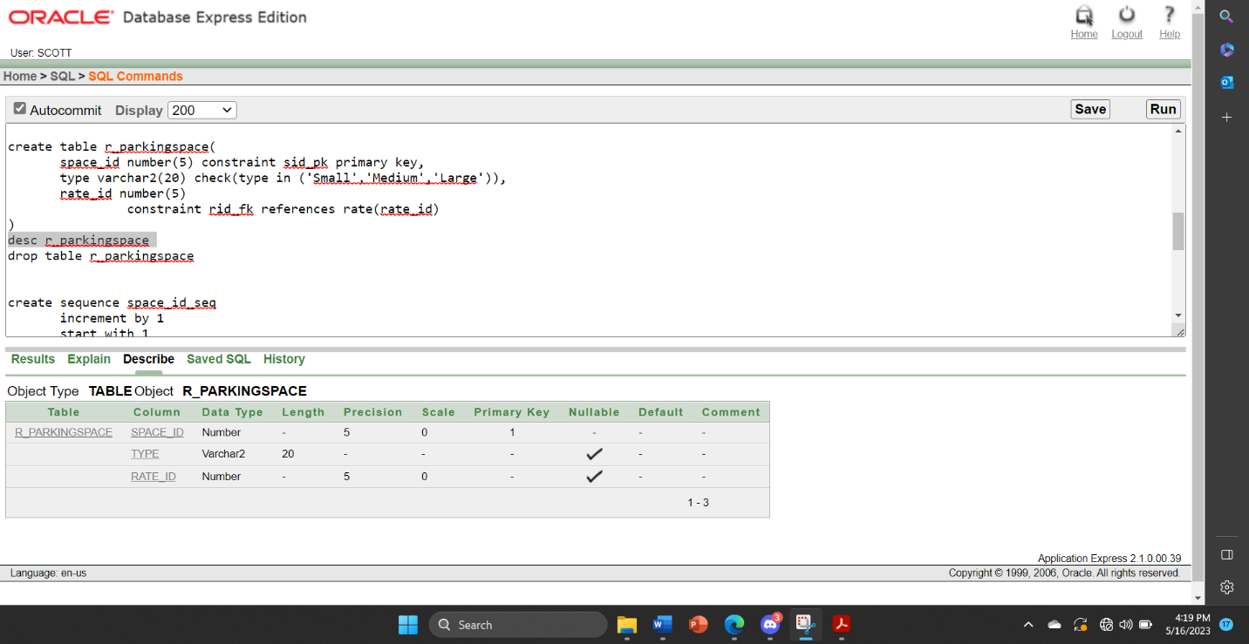

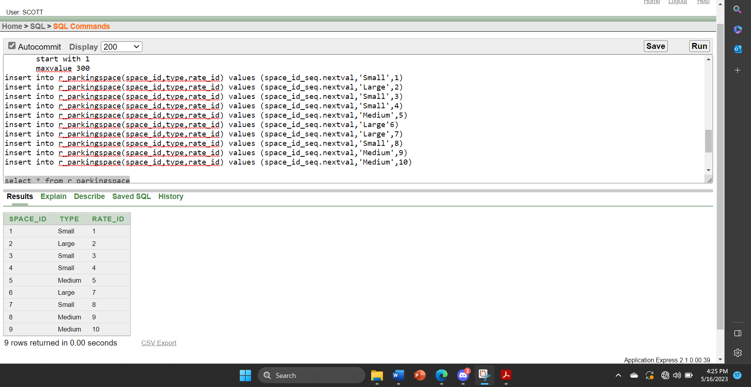

**RATE TABLE:**

create table rate

( rate_id number(5) constraint rid_pk primary key, hourly_rate number(10) not null,

day_rate number(10) not null,

type varchar2(20) check(type in ('Small','Medium','Large')) )

desc rate

drop table rate

create sequence rate_seq

increment by 1

start with 1

maxvalue 200

insert into rate(rate_id,hourly_rate,day_rate,type) values (rate_seq.nextval,100,700,'Small')

insert into rate(rate_id,hourly_rate,day_rate,type) values (rate_seq.nextval,250,2000,'Large')

insert into rate(rate_id,hourly_rate,day_rate,type) values (rate_seq.nextval,100,700,'Small')

insert into rate(rate_id,hourly_rate,day_rate,type) values (rate_seq.nextval,100,700,'Small')

insert into rate(rate_id,hourly_rate,day_rate,type) values (rate_seq.nextval,170,1200,'Medium')

insert into rate(rate_id,hourly_rate,day_rate,type) values (rate_seq.nextval,250,2000,'Large')

insert into rate(rate_id,hourly_rate,day_rate,type) values (rate_seq.nextval,250,2000,'Large')

insert into rate(rate_id,hourly_rate,day_rate,type) values (rate_seq.nextval,100,700,'Small')

insert into rate(rate_id,hourly_rate,day_rate,type) values (rate_seq.nextval,170,1200,'Medium')

insert into rate(rate_id,hourly_rate,day_rate,type) values (rate_seq.nextval,170,1200,'Medium')

select * from rate

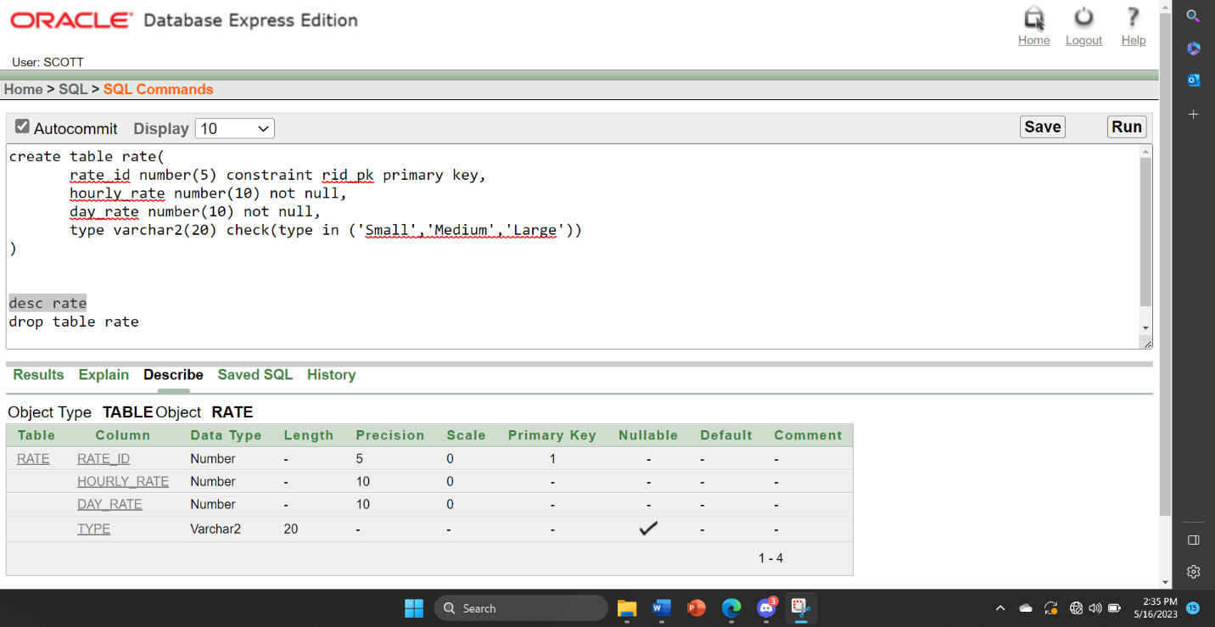

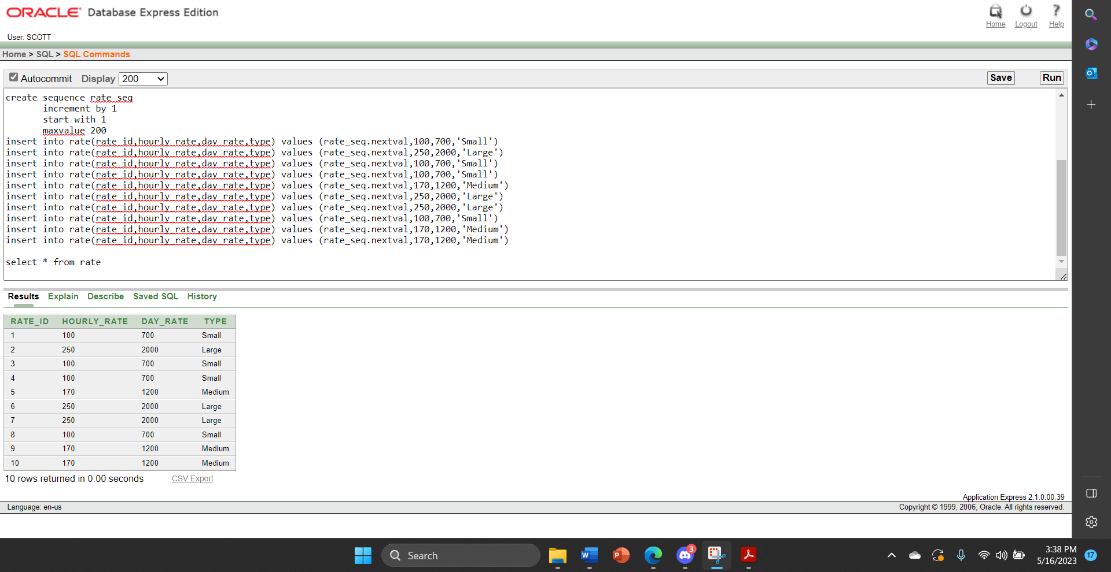

**EMPLOYEE TABLE:**

create table employee

(employee_id number(5) constraint employee_emid_pk primary key,

first_name varchar2(20) not null,

last_name varchar2(20),

hire_date date not null,

salary number(10) not null,

manager_id number(5) constraint mngid_fk references manager(manager_id) not null)

desc employee

drop table employee

insert into employee(employee_id,first_name,Last_name,hire_date,salary,manager_id) values(100,'Rahim','khan','06-FEB-20',15000,150)

insert into employee(employee_id,first_name,Last_name,hire_date,salary,manager_id) values(200,'Rana ','Ialam','28-MAR-21',12000,150)

insert into employee(employee_id,first_name,Last_name,hire_date,salary,manager_id) values(300,'Salman','Shihab','14-JUL-18',25000,150)

insert into employee(employee_id,first_name,Last_name,hire_date,salary,manager_id) values(400,'Badhon','Bishwas','17-JAN-08',18000,350)

insert into employee(employee_id,first_name,Last_name,hire_date,salary,manager_id) values(500,'Nahid','Khan','06-DEC-19',20000,350)

insert into employee(employee_id,first_name,Last_name,hire_date,salary,manager_id) values(600,'Jorina','Khatun','01-MAY-15',13000,350)

insert into employee(employee_id,first_name,Last_name,hire_date,salary,manager_id) values(700,'karim','Mirza','12-JUN-22',14000,450)

insert into employee(employee_id,first_name,Last_name,hire_date,salary,manager_id) values(800,'Hero','Alam','15-JAN-17',10000,450)

insert into employee(employee_id,first_name,Last_name,hire_date,salary,manager_id) values(900,'Chengish','Khan','17-JAN-11',17000,450)

insert into employee(employee_id,first_name,Last_name,hire_date,salary,manager_id) values(1000,'Abdur','rahman','21-DEC-20',19000,250)

insert into employee(employee_id,first_name,Last_name,hire_date,salary,manager_id) values(1100,'Will','Smith','10-JUN-18',29000,250)

insert into employee(employee_id,first_name,Last_name,hire_date,salary,manager_id) values(1200,'Shekh','Hassina','07-FEB-03',1000,250)

select * from employee

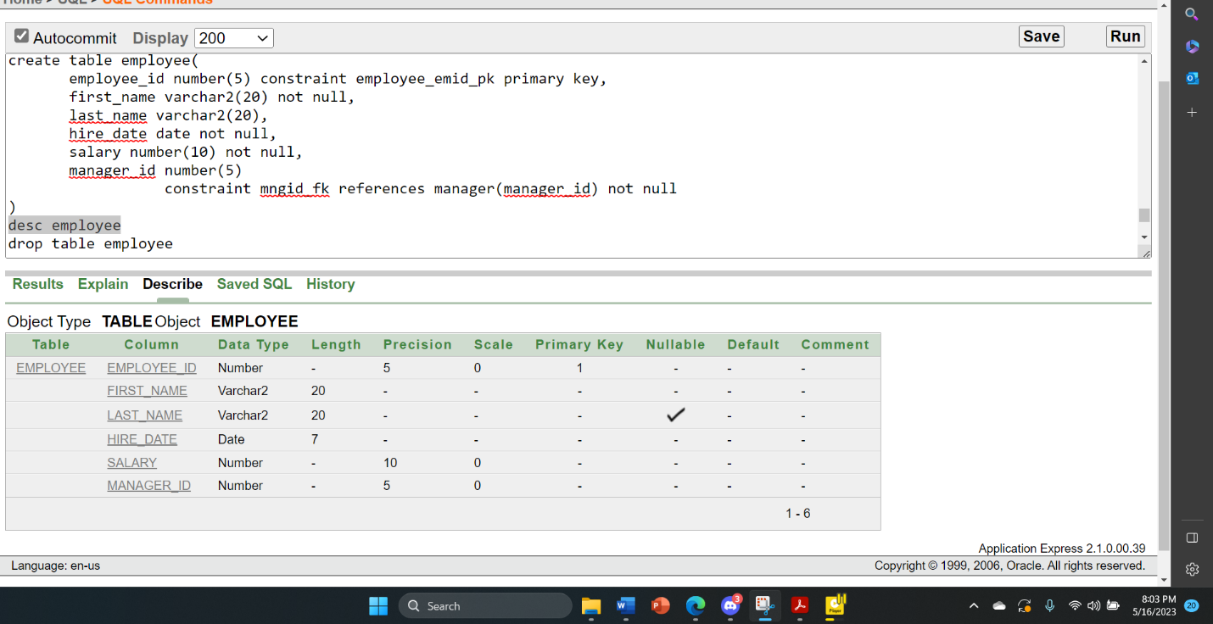

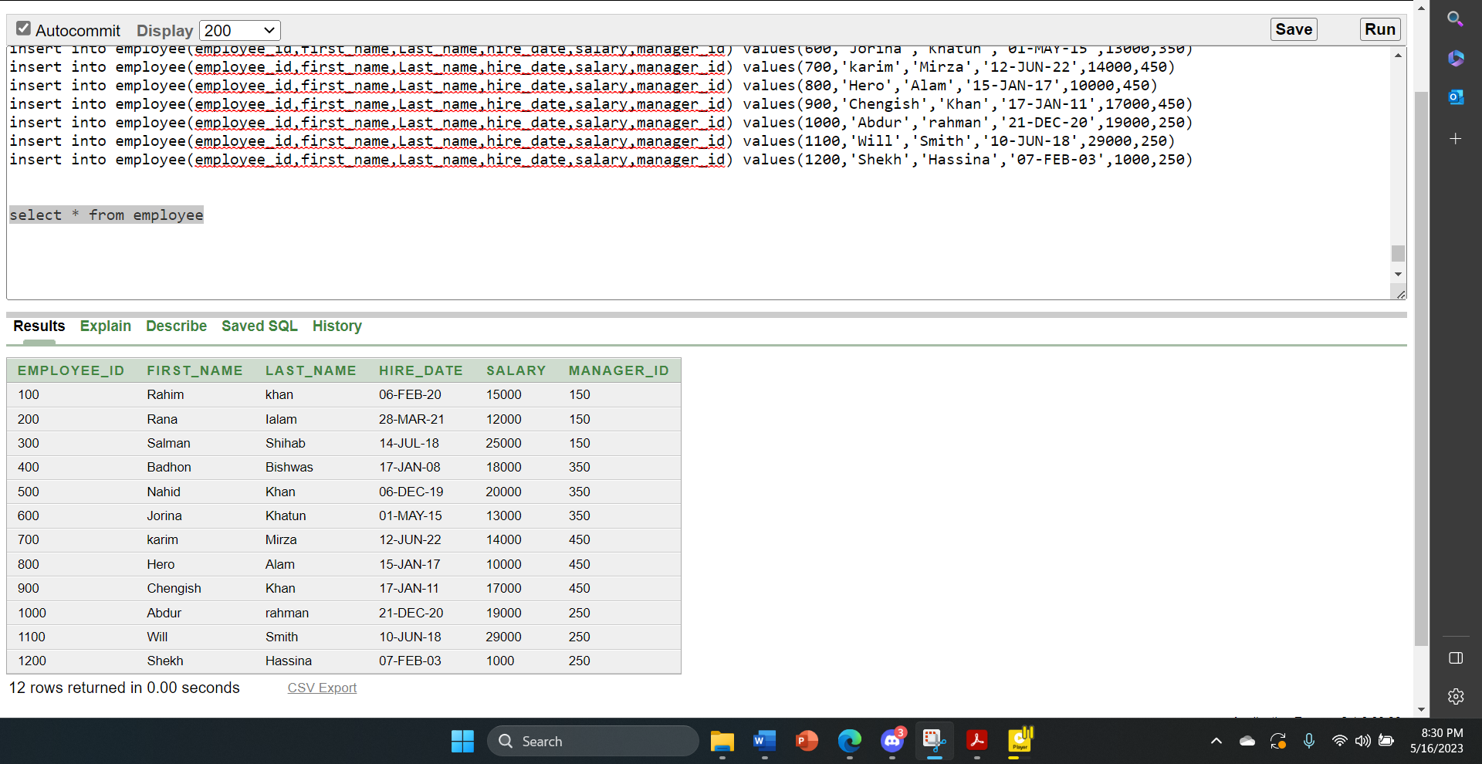

**E_PHONENUMBER TABLE:**

create table e_phonenumber

( phone_number number(10) unique not null,

employee_id number(5) constraint emid_fk references employee(employee_id) not null )

desc e_phonenumber

drop table e_phonenumber

insert into e_phonenumber(employee_id,phone_number) values(100,01756324896)

insert into e_phonenumber(employee_id,phone_number) values(200,01824526126)

insert into e_phonenumber(employee_id,phone_number) values(300,01646554852)

insert into e_phonenumber(employee_id,phone_number) values(400,01648423541)

insert into e_phonenumber(employee_id,phone_number) values(500,01756395463)

insert into e_phonenumber(employee_id,phone_number) values(600,01756378521)

insert into e_phonenumber(employee_id,phone_number) values(700,01956885776)

insert into e_phonenumber(employee_id,phone_number) values(800,01856654823)

insert into e_phonenumber(employee_id,phone_number) values(900,01654854228)

insert into e_phonenumber(employee_id,phone_number) values(1000,01751234897)

insert into e_phonenumber(employee_id,phone_number) values(1100,01562486248)

insert into e_phonenumber(employee_id,phone_number) values(1200,01888888111)

select * from e_phonenumber

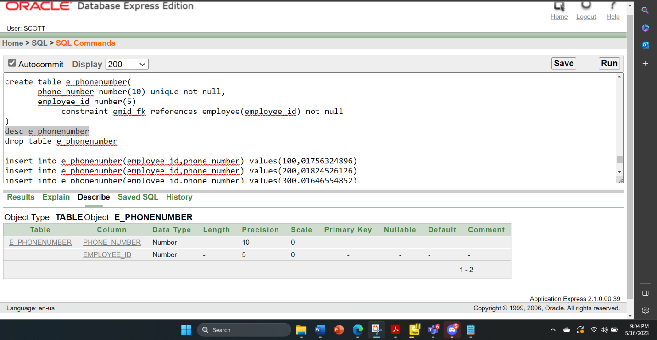



**FINE TABLE:**

create table fine

( fine_id number(5) constraint fid_pk primary key,

issue_date date not null,

paid_date date not null,

amount number(10) not null,

manager_id number(5) constraint fmid_fk references manager(manager_id) not null)

desc fine

drop table fine

insert into fine (fine_id,issue_date,paid_date,amount,manager_id) values (01,'08-dec-22','09-dec-22',70,150)

insert into fine (fine_id,issue_date,paid_date,amount,manager_id) values (02,'11-dec-22','12-dec-22',120,150)

insert into fine (fine_id,issue_date,paid_date,amount,manager_id) values (03,'12-feb-22','18-feb-22',200,150)

insert into fine (fine_id,issue_date,paid_date,amount,manager_id) values (04,'15-mar-21','20-mar-21',300,250)

insert into fine (fine_id,issue_date,paid_date,amount,manager_id) values (05,'20-jul-20','27-jul-20',250,250)

insert into fine (fine_id,issue_date,paid_date,amount,manager_id) values (06,'20-dec-19','22-dec-19',500,350)

insert into fine (fine_id,issue_date,paid_date,amount,manager_id) values (07,'10-jan-23','15-jan-23',1000,450)

insert into fine (fine_id,issue_date,paid_date,amount,manager_id) values (08,'08-jun-22','11-jun-22',100,250)

insert into fine (fine_id,issue_date,paid_date,amount,manager_id) values (09,'14-dec-17','18-dec-17',100,350)

insert into fine (fine_id,issue_date,paid_date,amount,manager_id) values (010,'17-dec-16','20-dec-16',100,450)

select * from fine

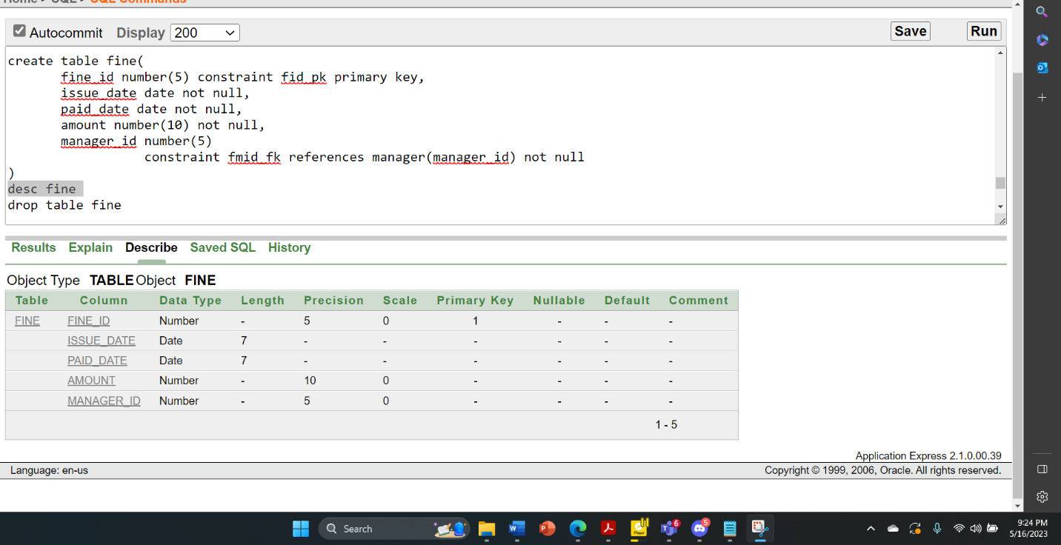

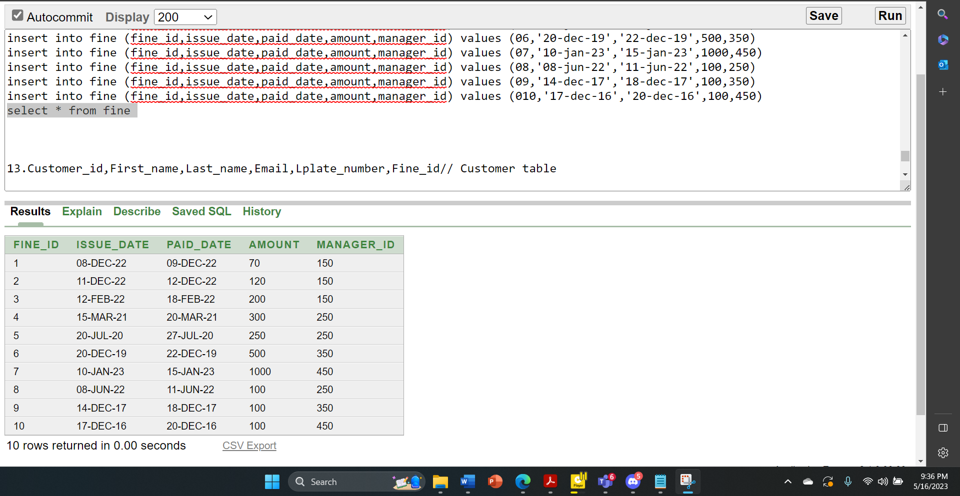

**CUSTOMER TABLE:**

create table customer(

customer_id number(5) constraint customer_cid_pk primary key,

first_name varchar2(20) not null,

last_name varchar2(20),

email varchar2(50),

lplate_number varchar2(20) unique not null,

fine_id number(5)

constraint customer_fid_fk references fine(fine_id) not null

)

desc customer

drop table customer

insert into customer(customer_id,first_name,last_name,email,lplate_number,fine_id)values(111,'Winston','Taylor','instonaylor@gmail.com','KA 45-2422',03)

insert into customer(customer_id,first_name,last_name,email,lplate_number,fine_id ) values(222,'Jean','Fleaur','jeanfleaur@gmail.com','KA 34-3243',08)

insert into customer(customer_id,first_name,last_name,email,lplate_number,fine_id ) values(333,'Nandita','Sarchand','nanditasarchand@gmail.com','GA 22-1232',01)

insert into customer(customer_id,first_name,last_name,email,lplate_number,fine_id ) values(444,'Alexis','Bull','alexisbull@gmail.com','KA 33-4332',02)

insert into customer(customer_id,first_name,last_name,email,lplate_number,fine_id ) values(555,'Julia','Dellinger','juliadellinger@gmail.com','KA 65-4534',03)

insert into customer(customer_id,first_name,last_name,email,lplate_number,fine_id ) values(666,'Anthony','Cabrio','anthonycabrio@gmail.com','KHA 25-4311',04)

insert into customer(customer_id,first_name,last_name,email,lplate_number,fine_id ) values(777,'Kelly','Chung','kellychung@gmail.com','CA 25-2432',05)

insert into customer (customer_id,first_name,last_name,email,lplate_number,fine_id ) values(888,'Jennifer','Dilly','jenniferdilly@gmail.com','KA 53-2423',09)

insert into customer(customer_id,first_name,last_name,email,lplate_number,fine_id ) values(999,'Timothy','Gates','timothygates@gmail.com','KA 43-2422',08)

insert into customer(customer_id,first_name,last_name,email,lplate_number,fine_id ) values(1010,'Randall','Perkins','randallperkins@gmail.com','KA 62-1434',07)

insert into customer(customer_id,first_name,last_name,email,lplate_number,fine_id ) values(1111,'Sarah','Bell','sarahbell@gmail.com','KHA 51-5234',06)

insert into customer(customer_id,first_name,last_name,email,lplate_number,fine_id ) values(1212,'Britney','Everett','britneyeverett@gmail.com','KHA 53-6423',010)

select * from customer

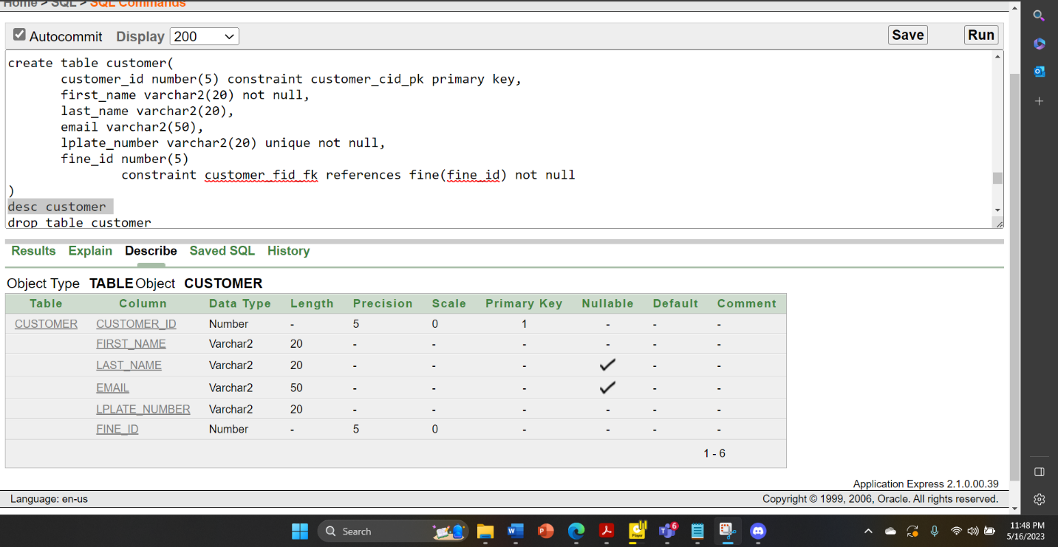

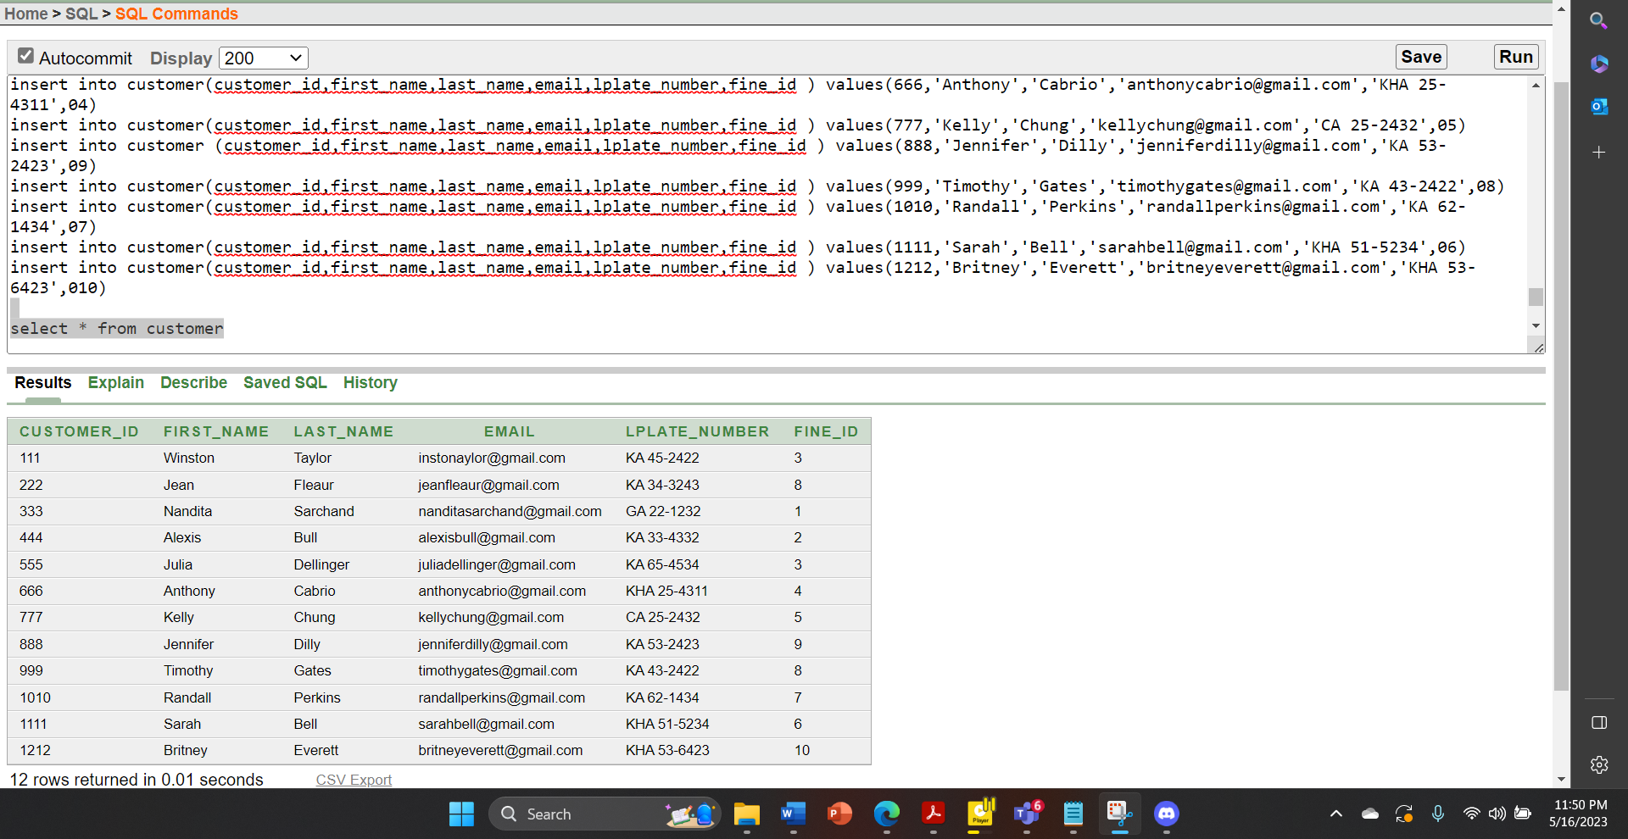

**C_PHONENUMBER TABLE:**

create table c_phonenumber

( Phone_number number(20) unique not null,

customer_id number(5) constraint cid_fk references customer(customer_id) not null)

desc c_phonenumber

drop table c_phonenumber

insert into c_phonenumber(customer_id,phone_number ) values(111,0183164675)

insert into c_phonenumber(customer_id,phone_number ) values(222,0175424855)

insert into c_phonenumber(customer_id,phone_number ) values(333,0146546555)

insert into c_phonenumber(customer_id,phone_number ) values(444,0153215655)

insert into c_phonenumber(customer_id,phone_number ) values(555,0134849122)

insert into c_phonenumber(customer_id,phone_number ) values(666,0183164678)

insert into c_phonenumber(customer_id,phone_number ) values(888,0189454525)

insert into c_phonenumber(customer_id,phone_number ) values(999,0183164679)

insert into c_phonenumber(customer_id,phone_number ) values(1111,0178585858)

insert into c_phonenumber(customer_id,phone_number ) values(1212,0199911224)

select * from c_phonenumber

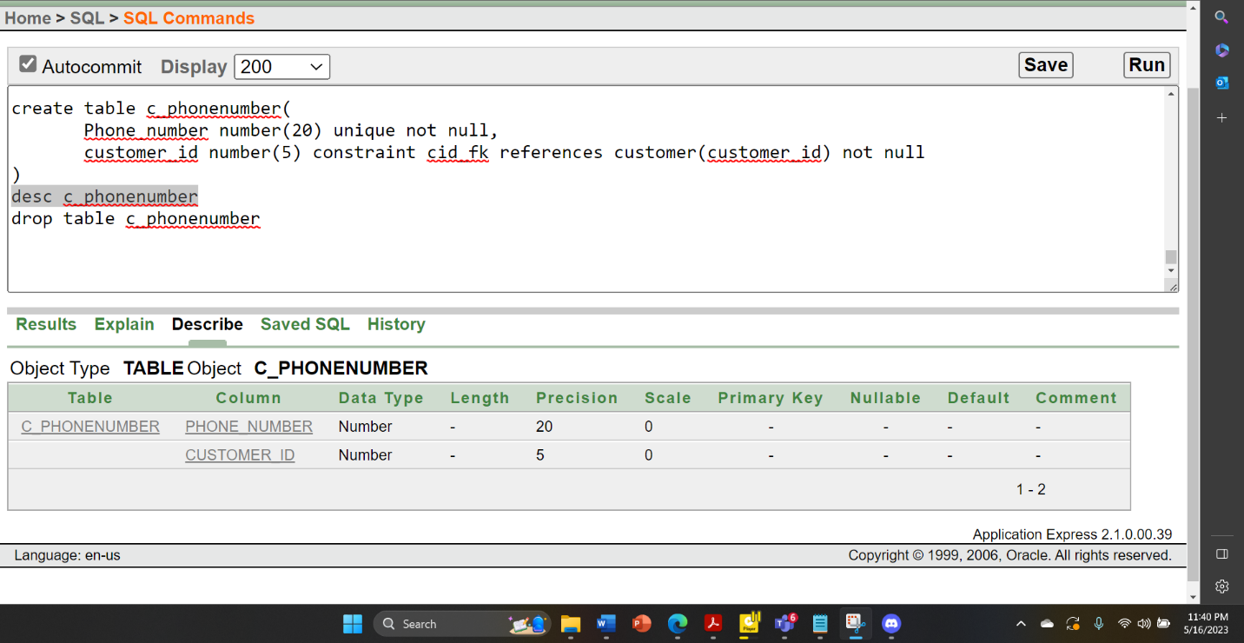

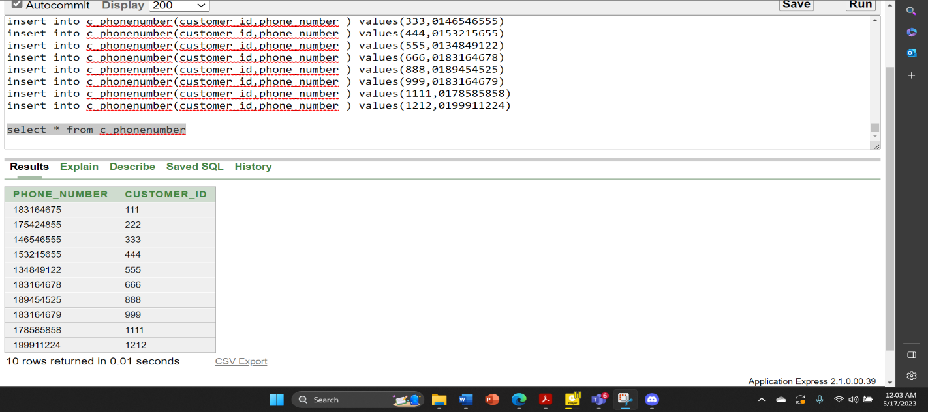

**C_ADDRESS TABLE:**

create table c_address

( city varchar2(20) not null,

country varchar2(20) not null,

customer_id number(5) constraint ccid_fk references customer(customer_id) not null)

desc c_address

drop table c_address

insert into c_address(customer_id,city,country ) values(111,'Dellas','USA')

insert into c_address(customer_id,city,country ) values(222,'Amsterdam','Netherlands')

insert into c_address(customer_id,city,country ) values(333,'Texas','USA')

insert into c_address(customer_id,city,country )

values(444,'Bharmingham','Uk')

insert into c_address(customer_id,city,country ) values(555,'London','Uk')

insert into c_address(customer_id,city,country ) values(666,'California','USA')

insert into c_address(customer_id,city,country ) values(777,'San Diego','USA')

insert into c_address(customer_id,city,country ) values(888,'San Francisco','USA')

insert into c_address(customer_id,city,country ) values(999,'Miami','USA')

insert into c_address(customer_id,city,country ) values(1010,'Florida','USA')

insert into c_address(customer_id,city,country ) values(1111,'New York','USA')

insert into c_address(customer_id,city,country ) values(1212,'Orange County','USA')

select * from c_address

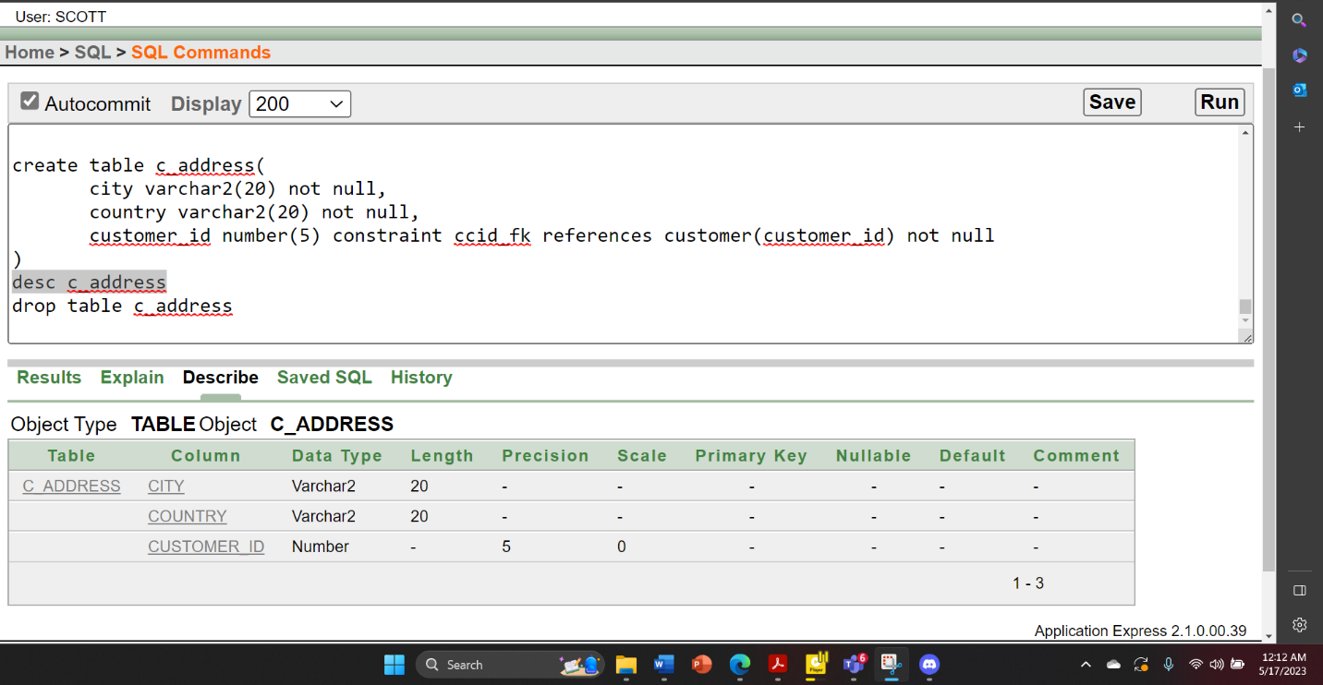

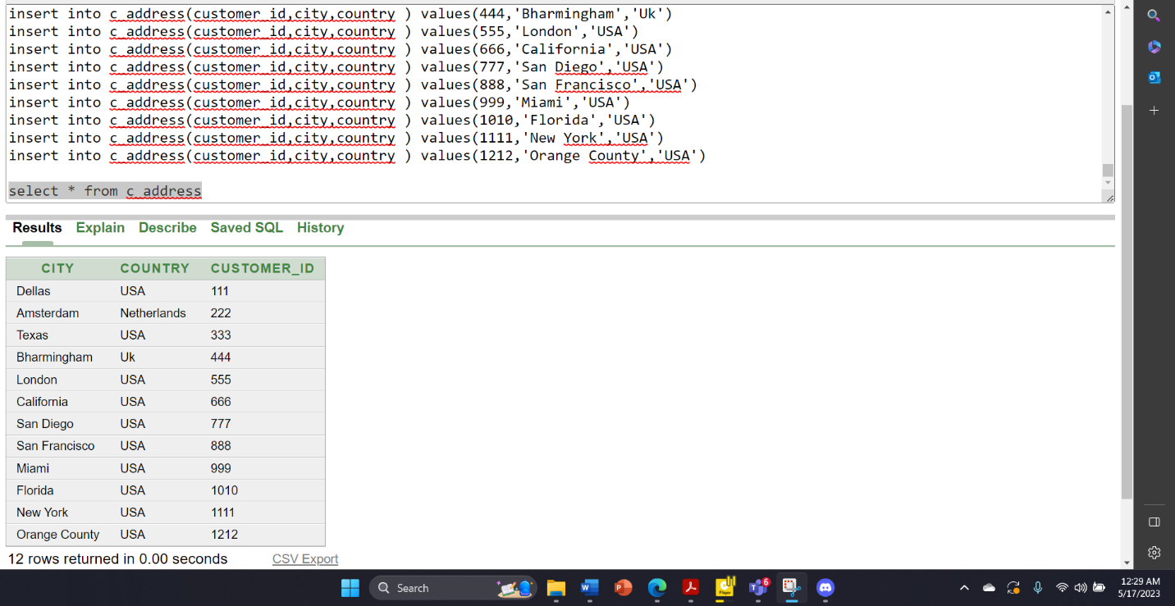

**C_PARKINGSLIP TABLE:**

create table c_parkingslip

(parking_slip_id number(5) constraint psid_pk primary key,

issue_date date not null,

expair_date date not null,

type varchar2(30) check(type in ('small','medium','large')) not null,

customer_id number(5)

constraint pcid_fk references customer(customer_id) not null)

desc c_parkingslip

drop table c_parkingslip

insert into c_parkingslip(parking_slip_id,issue_date,expair_date,type,

customer_id) values(1,'09-dec-22','10-dec-22','small',111)

insert into c_parkingslip(parking_slip_id,issue_date,expair_date,type,

customer_id) values(2,'10-dec-22','11-dec-22','medium',222)

insert into c_parkingslip(parking_slip_id,issue_date,expair_date,type,

customer_id) values(3,'11-dec-22','12-dec-22','small',333)

insert into c_parkingslip(parking_slip_id,issue_date,expair_date,type,

customer_id) values(4,'12-dec-22','13-dec-22','small',444)

insert into c_parkingslip(parking_slip_id,issue_date,expair_date,type,

customer_id) values(5,'12-dec-22','14-dec-22','large',555)

insert into c_parkingslip(parking_slip_id,issue_date,expair_date,type,

customer_id) values(6,'13-dec-22','16-dec-22','small',666)

insert into c_parkingslip(parking_slip_id,issue_date,expair_date,type,

customer_id) values(7,'16-dec-22','17-dec-22','large',777)

insert into c_parkingslip(parking_slip_id,issue_date,expair_date,type,

customer_id) values(8,'18-dec-22','20-dec-22','large',888)

insert into c_parkingslip(parking_slip_id,issue_date,expair_date,type,

customer_id) values(9,'19-dec-22','21-dec-22','small',999)

insert into c_parkingslip(parking_slip_id,issue_date,expair_date,type,

customer_id) values(10,'20-dec-22','23-dec-22','medium',1010)

insert into c_parkingslip(parking_slip_id,issue_date,expair_date,type,

customer_id) values(11,'24-dec-22','26-dec-22','medium',1111)

insert into c_parkingslip(parking_slip_id,issue_date,expair_date,type,

customer_id) values(12,'27-dec-22','29-dec-22','medium',1212)

select * from c_parkingslip

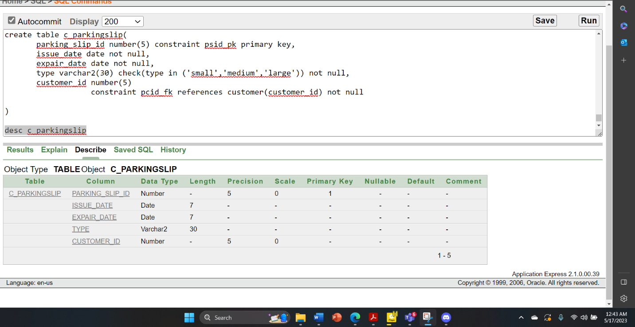

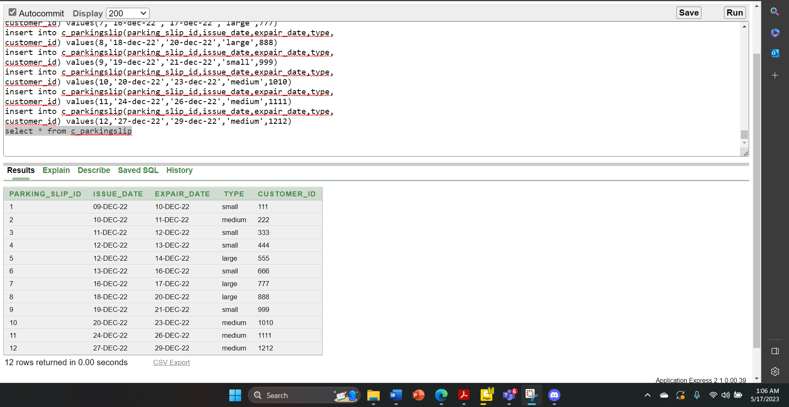

**S_PARKINGSLIP TABLE:**

create table s_parkingslip(

parking_slip_id number(5) constraint prsid_pk primary key,

issue_date date not null,

expair_date date not null,

type varchar2(30) check(type in ('small','medium','large')) not null,

space_id number(5)

constraint prspid_fk references parkingspace(space_id) not null)

desc s_parkingslip

drop table s_parkingslip

insert into s_parkingslip(parking_slip_id,issue_date,expair_date,type,

space_id) values(1,'09-dec-22','10-dec-22','small',1)

insert into s_parkingslip(parking_slip_id,issue_date,expair_date,type,

space_id) values(2,'10-dec-22','11-dec-22','medium',2)

insert into s_parkingslip(parking_slip_id,issue_date,expair_date,type,

space_id) values(3,'11-dec-22','12-dec-22','small',3)

insert into s_parkingslip(parking_slip_id,issue_date,expair_date,type,

space_id) values(4,'12-dec-22','13-dec-22','small',4)

insert into s_parkingslip(parking_slip_id,issue_date,expair_date,type,

space_id) values(5,'12-dec-22','14-dec-22','large',5)

insert into s_parkingslip(parking_slip_id,issue_date,expair_date,type,

space_id) values(6,'13-dec-22','16-dec-22','small',6)

insert into s_parkingslip(parking_slip_id,issue_date,expair_date,type,

space_id) values(7,'16-dec-22','17-dec-22','large',7)

insert into s_parkingslip(parking_slip_id,issue_date,expair_date,type,

space_id) values(8,'18-dec-22','20-dec-22','large',8)

insert into s_parkingslip(parking_slip_id,issue_date,expair_date,type,

space_id) values(9,'19-dec-22','21-dec-22','small',9)

insert into s_parkingslip(parking_slip_id,issue_date,expair_date,type,

space_id) values(10,'20-dec-22','23-dec-22','medium',10)

insert into s_parkingslip(parking_slip_id,issue_date,expair_date,type,

space_id) values(11,'24-dec-22','26-dec-22','medium',11)

insert into s_parkingslip(parking_slip_id,issue_date,expair_date,type,

space_id) values(12,'27-dec-22','29-dec-22','medium',12)

select * from s_parkingslip

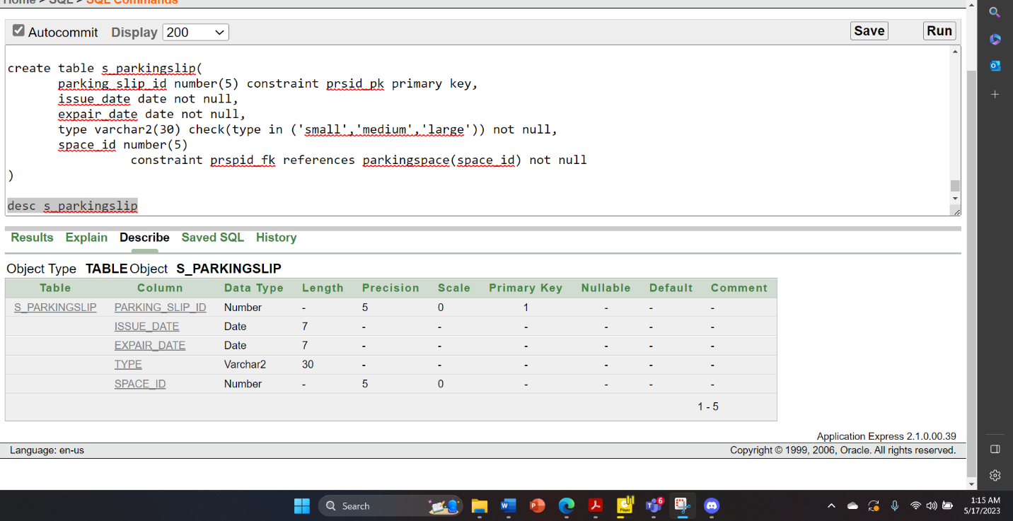

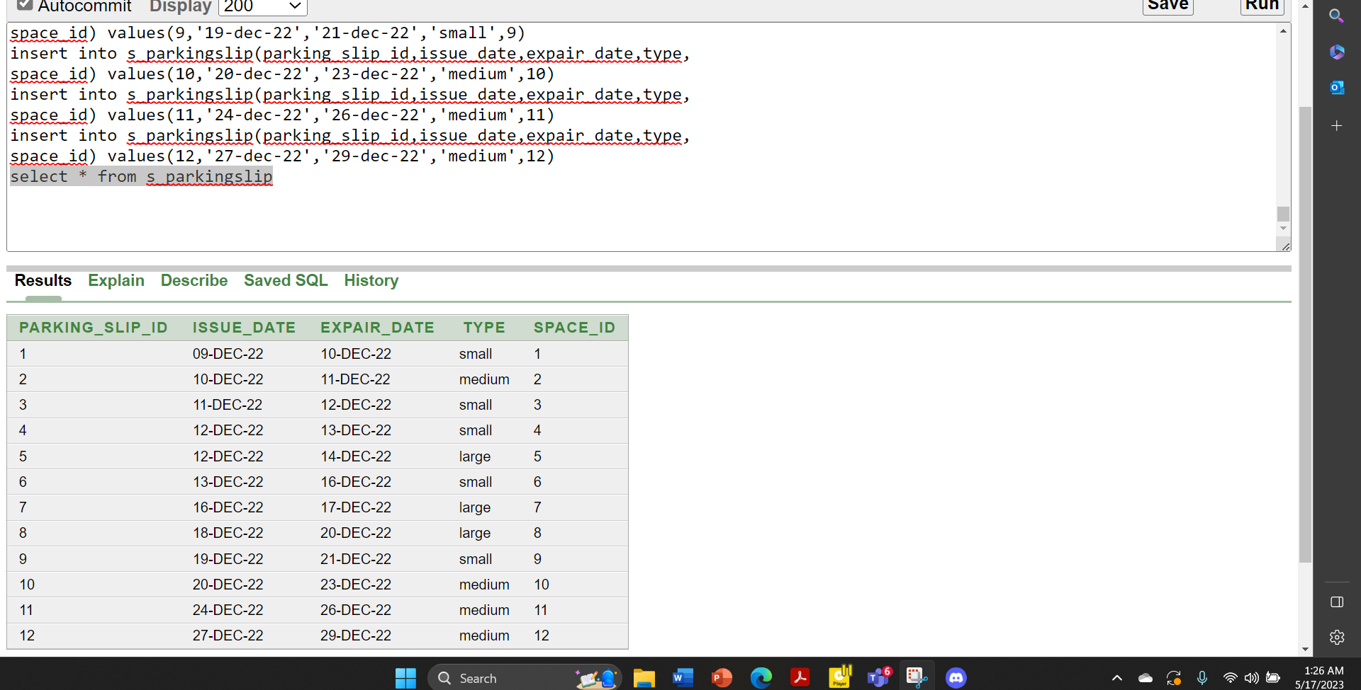

select * from employee

select * from manager

select * from e_phonenumber

select * from m_phonenumber

select * from customer

select * from c_phonenumber

select * from c_address

select * from fine

select * from s_parkingslip

select * from s_parkingslip

select * from parkingspace

select * from r_parkingspace

select * from parkingspot

select * from rate

**JOINNING:**

# Equijoin:

Display employee first name and their manager first name

select e.first_name as employee_name,m.first_name as manager_name

from employee e,manager m

where e.manager_id = m.manager_id

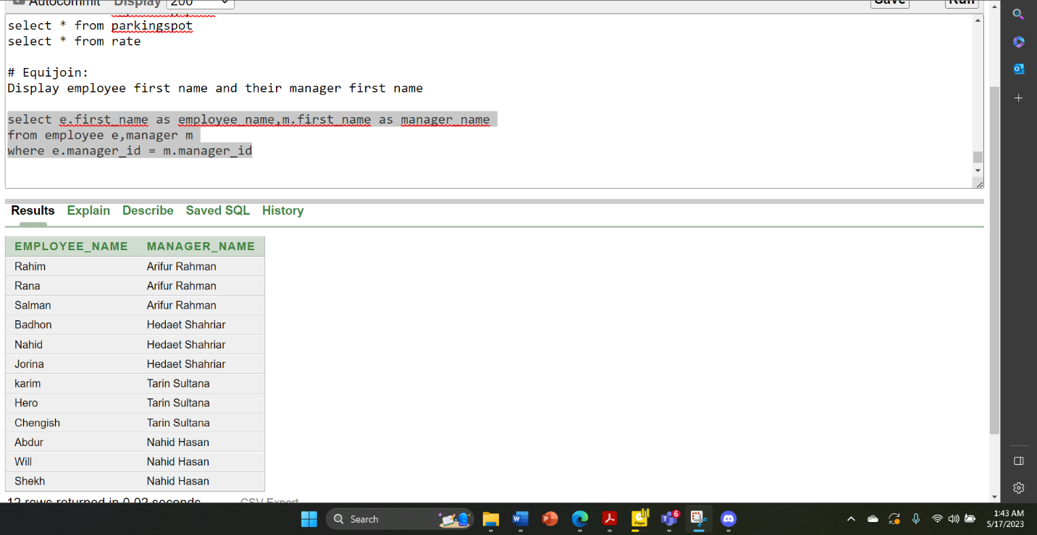

# Outerjoin:

1.Display the first name, last name for all employee who have or have not parking any car.

Select c.first_name,c.last_name,s.parking_slip_id,s.issue_date,s.expair_date from customer c ,c_parkingslip s

where c.customer_id=s.customer_id(+)

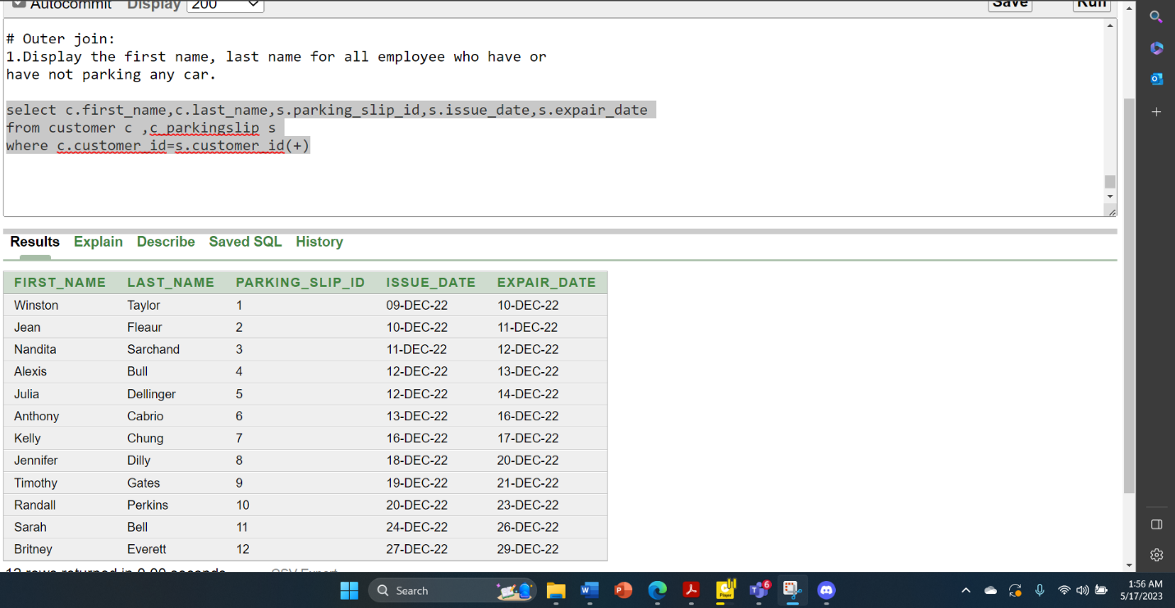

2.Display all the managers id,first name as manager_name who have emloyees under them and show the employee's first name as employee_name

select m.manager_id, m.first_name as manager_name ,e.first_name as employee_name

from manager m, employee e

where e.manager_id(+) = m.manager_id

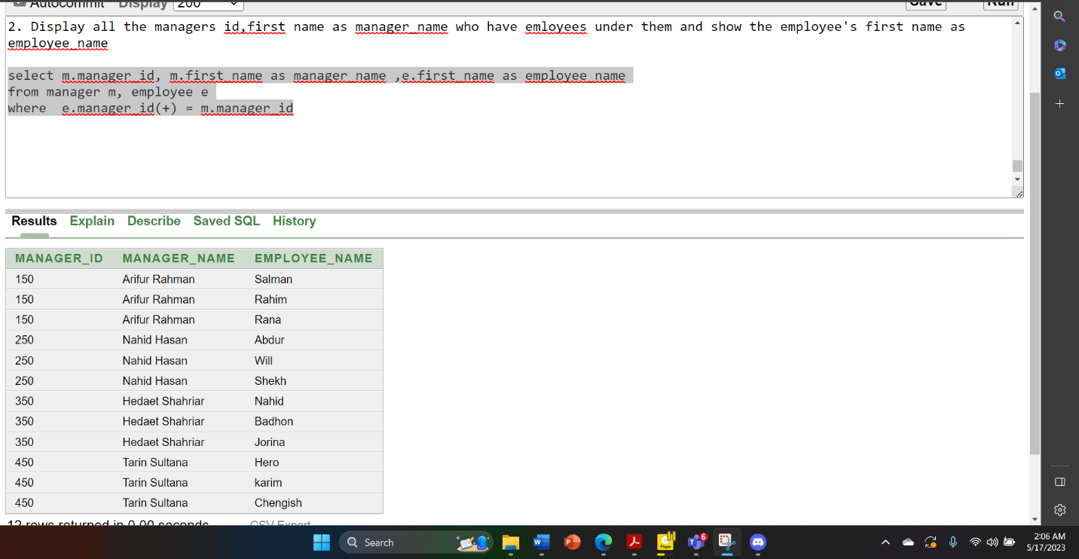

#Self-join:

Display the first and last name and salary for those employees who earn less than the employee earn whose empoyee_id is 500.

select e.first_name, e.last_name, e.salary

from employee e,employee s

where e.salary < s.salary and s.employee_id = 500

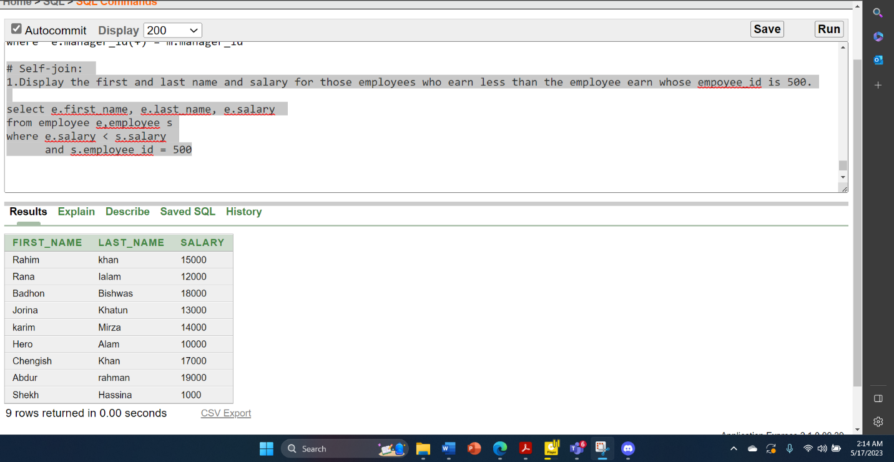

**SUBQUERY:**

1.Display the first name and salary for all employee who earn more than employee id 1200

select first_name ,salary

from employee

where salary>(select salary from employee where employee_id = 1200)

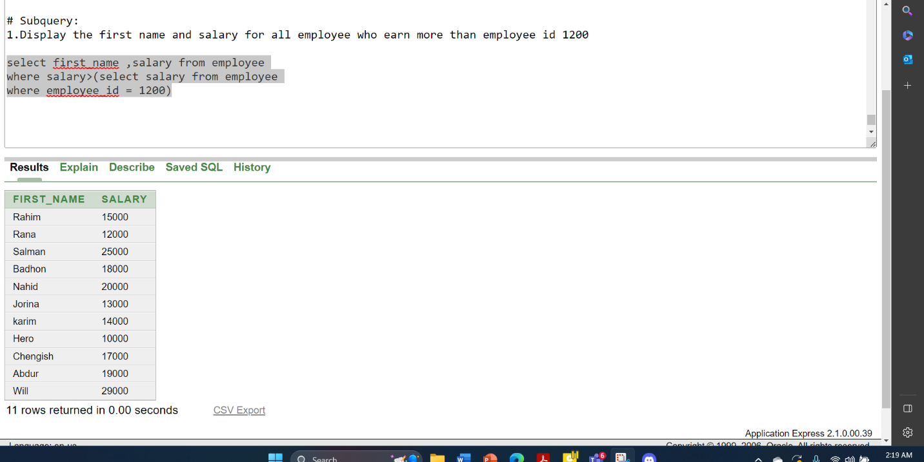

2.Display the last name and hire date for all employee who was hired after employee number 200

select first_name ,hire_date

from employee

where hire_date<

(select hire_date from employee where employee_id = 200)

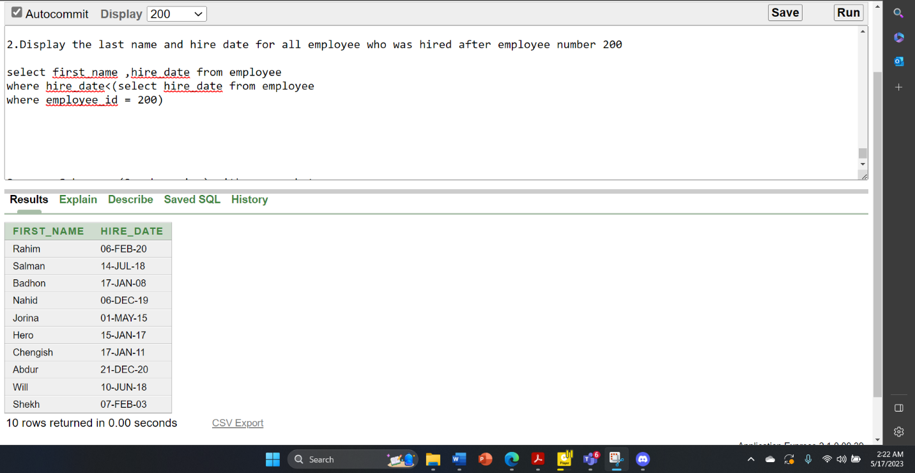

3.Display the first name and last name all employee whose manager's last name is Nobil

select first_name,last_name

from employee

where manager_id in (select manager_id from manager where last_name='Nobil')

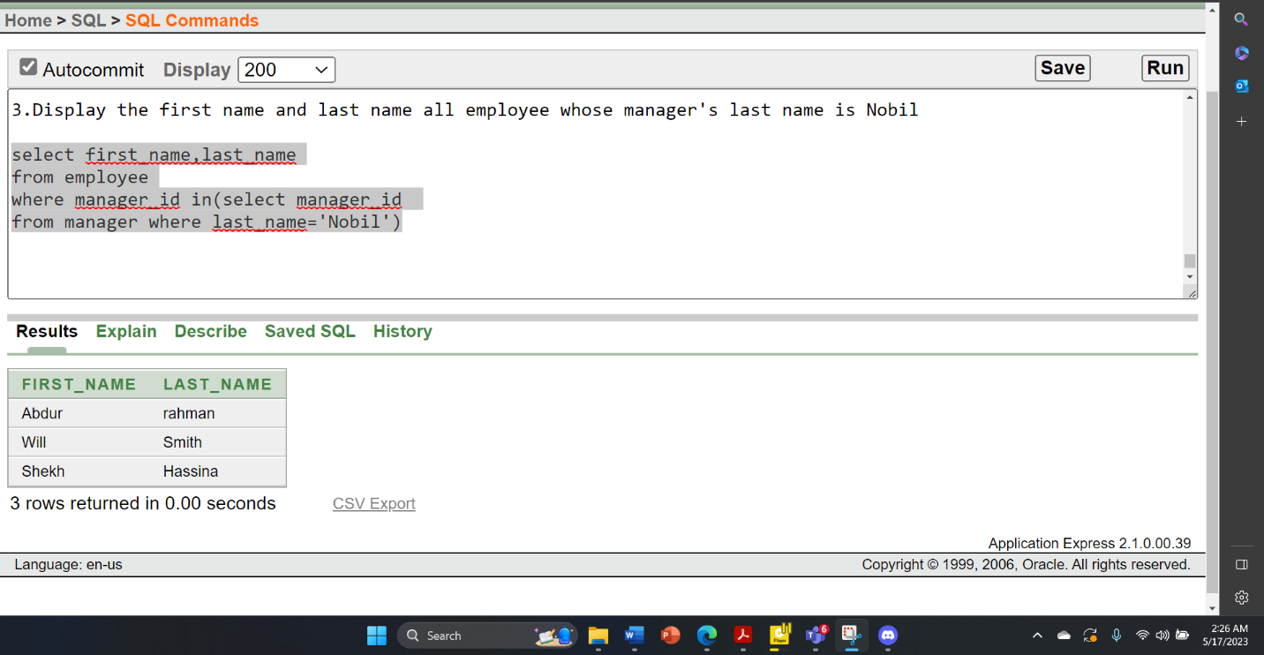

**VIEW:**

#simple view:

create view empview  
as select employee_id, first_name, salary from employee where manager_id= 250; select * from empview

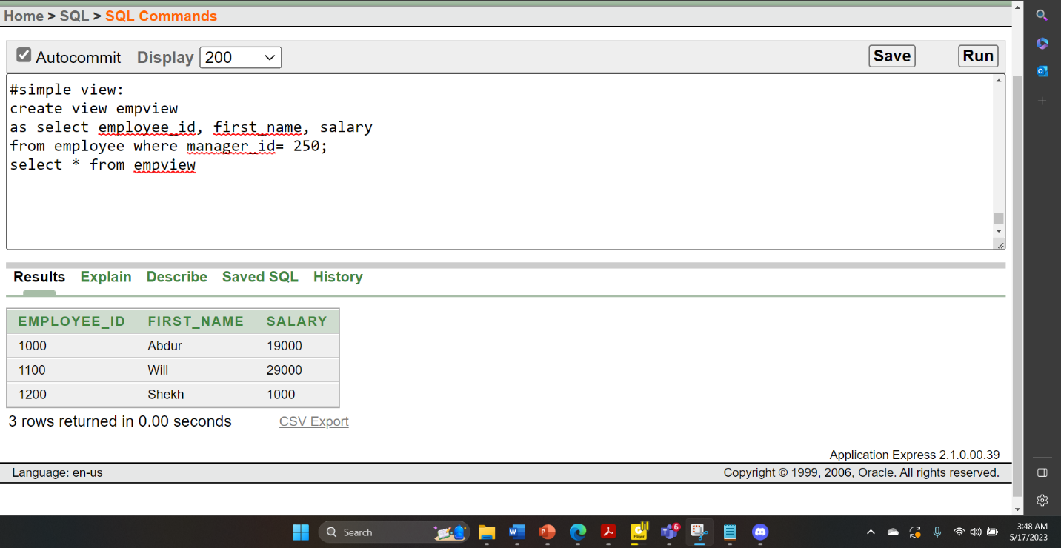

#complex view:

create view slip_details (customer_name,issue_date,expair_date,spot_id,space_id,space_type,spot_address)

as select c.first_name,pc.issue_date,pc.expair_date,sp.spot_id,s.space_id,

s.space_type,sp.city

from customer c,c_parkingslip pc,s_parkingslip ps,

parkingspace s,parkingspot sp

where c.customer_id = pc.customer_id and s.space_id = ps.space_id and s.spot_id=sp.spot_id

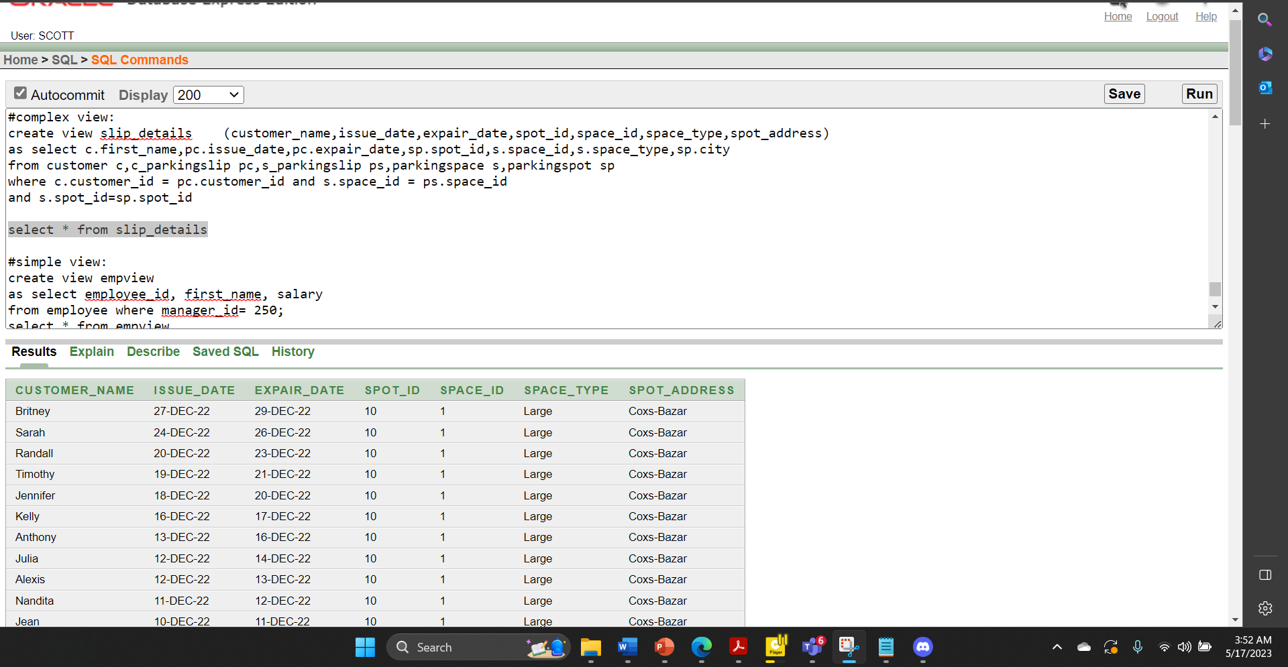

**ADD CONSTRAINT:**

Add unique constraint in customer table with the email column

Alter table customer add constraint cuq unique (email);

